

  
  LACAVA Price List 2026 will go into effect on March 30, 2026.
  
  Please be sure to download the Excel file and integrate it into your system.

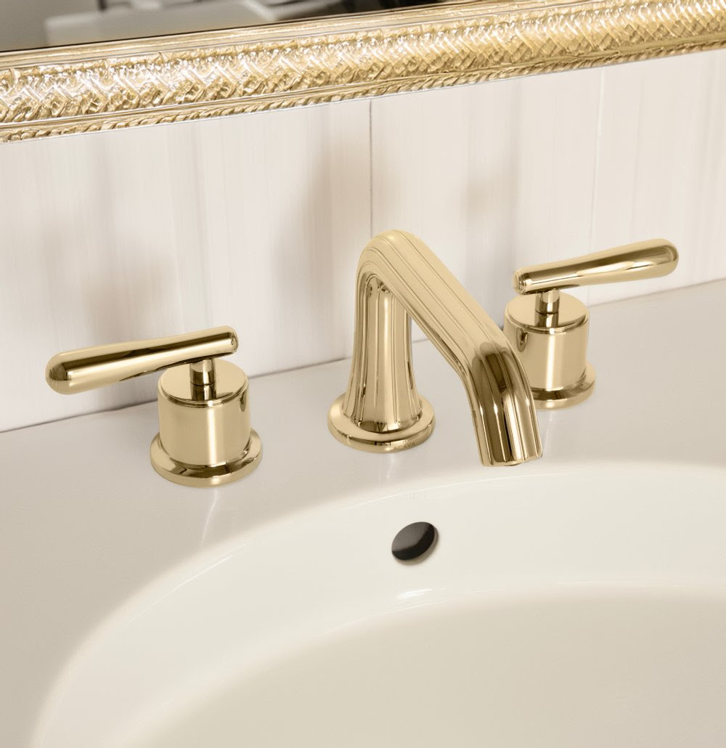

Refined Lives Call for Unparalleled Choice & Quality!

Our newest Flutti Faucet Collection is a sophisticated expression of mid-century modern design, where classic elegance meets refined simplicity. Defined by graceful, delicate lines, the collection offers deck-mount faucets for both single-hole and three-hole widespread installations, wide selection of shower and tub valves, tub fillers and shower heads.
﻿Crafted from solid brass and equipped with precision ceramic disc cartridges, Flutti delivers enduring performance and exceptional quality. Offered in a curated selection of luxurious finishes, with smooth or fluted detailing and a choice of J-shaped, T-shaped, or X-handles, the collection embodies remarkable versatility. From concept to completion, Flutti invites endless design expression—elevating the everyday bathroom with effortless, flowing style.

Our Faucet and Valve collections are designed to outfit your entire bathroom with timeless fixtures that transcend trends, deliver exceptional functionality, and elevate your space for years to come.

Shown: Flutti 1683F-HP2 fluted spout with P-handles in polished bronze

EXPLORE FLUTTI FAUCET COLLECTION



FAUCETS

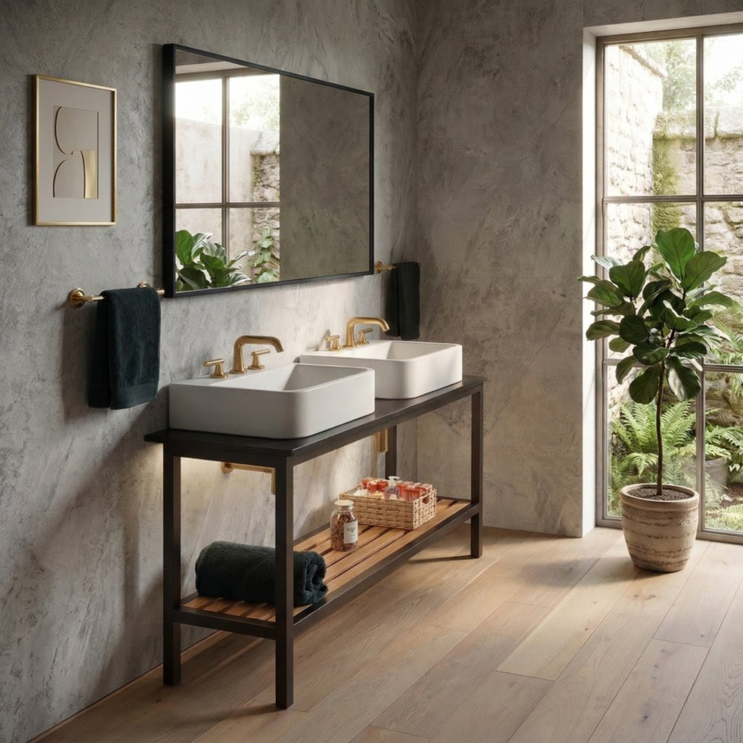

The collection is available in 12 beautiful finishes from warm and rich tones and hues of gold and bronze to subtle elegance and refinement of titanium and matte black, while delicate flutes flowing along the silhouette add a touch of texture. The advanced technology of PVD coating we use ensures superior performance in terms of strength and durability.



  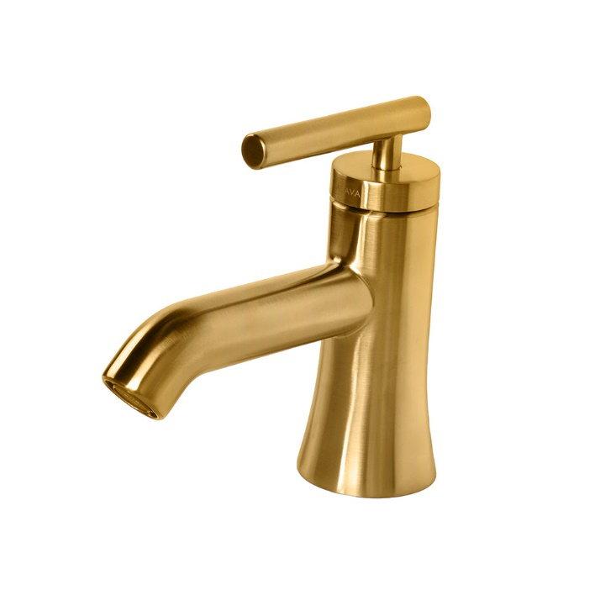
  Flutti with T-handle, in brushed gold
  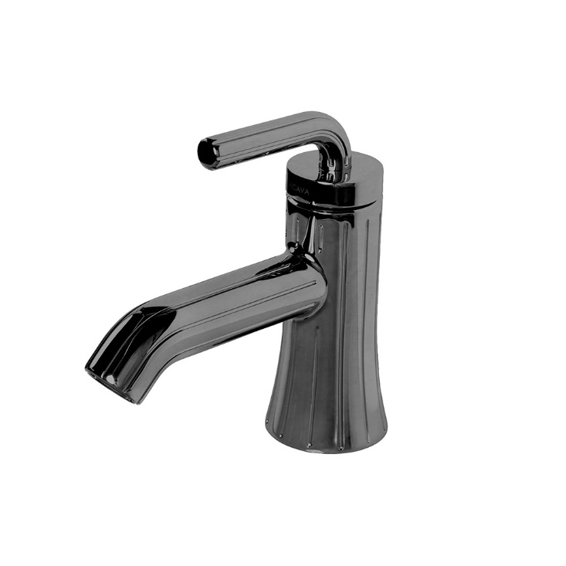
  Flutti with J-handle, in black chrome

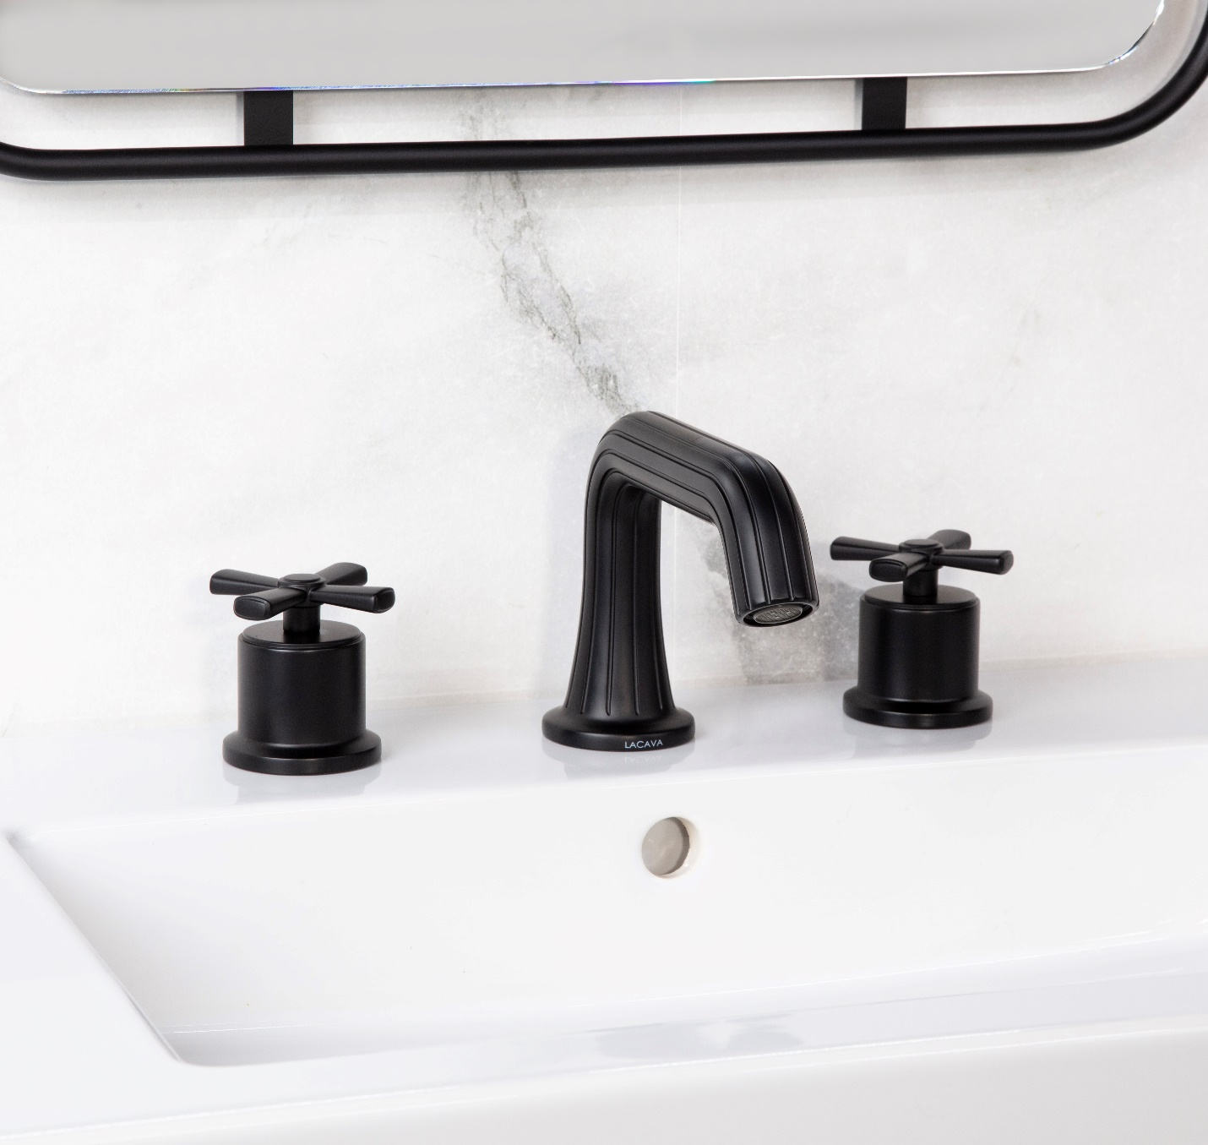

SHOWER VALVES

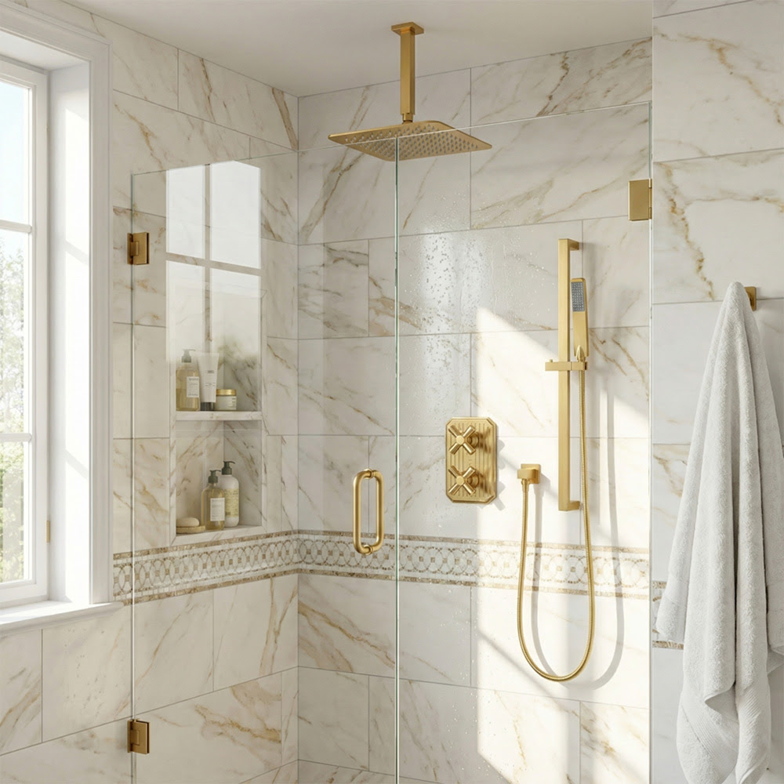

  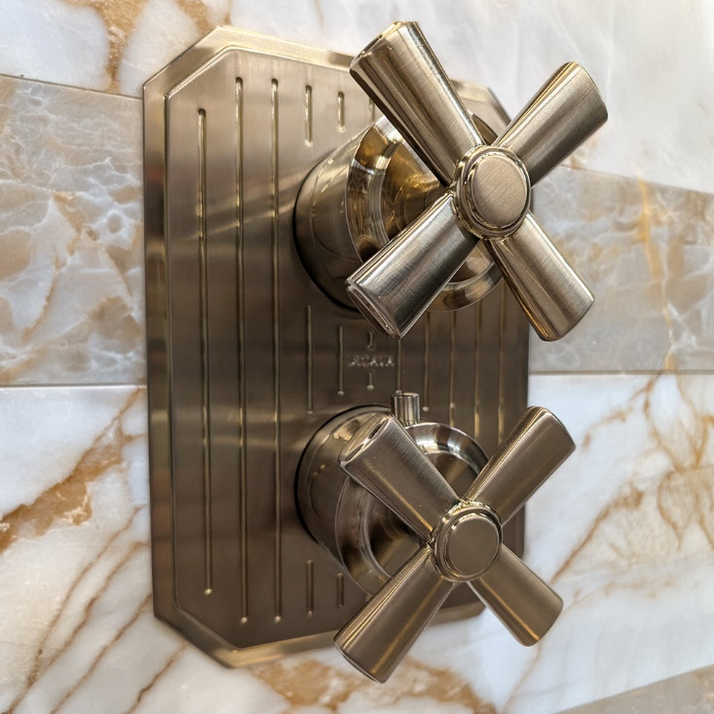
  Flutti thermostatic valve w/3 outlets
  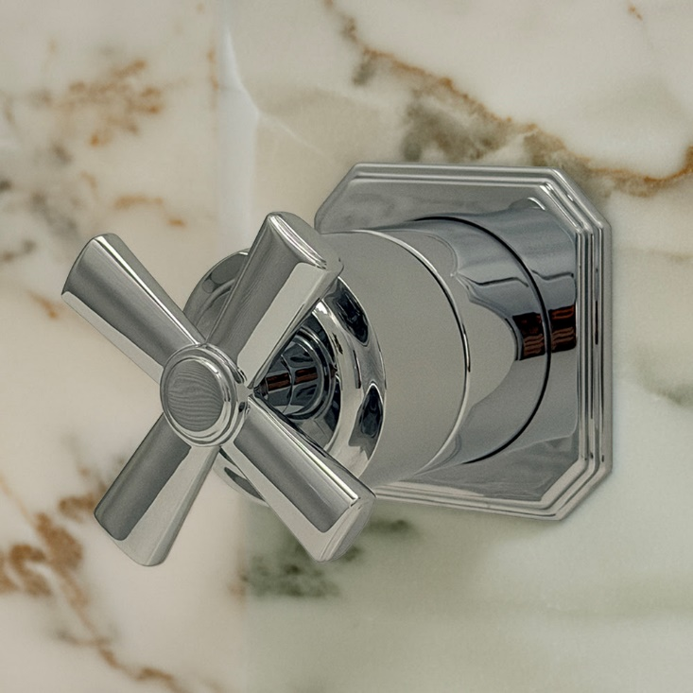
  Flutti stop valve

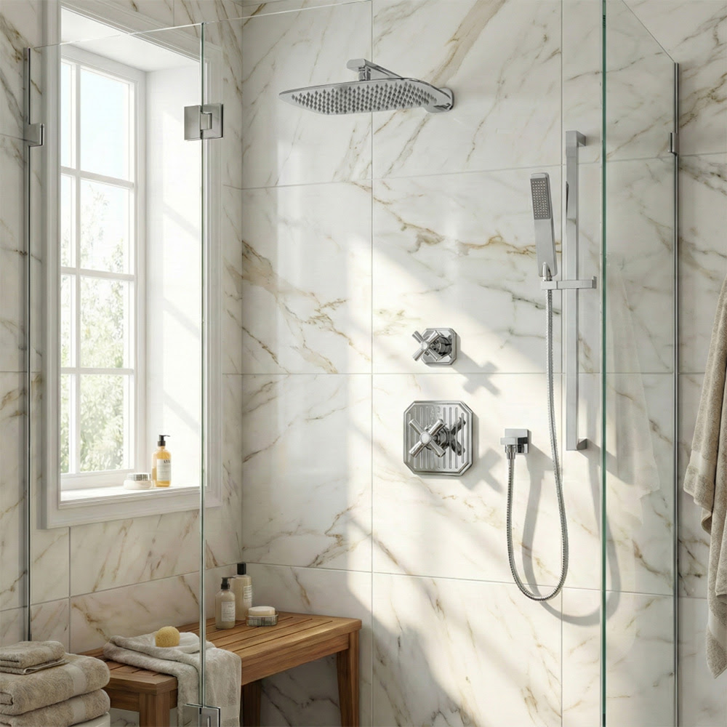

Our online configurator found on the product pages makes the process of selecting the right valves matching the bathing and showering needs fast and easy. Shared trims that fit the universal rough-ins alleviate the pressure and urgency from hasty style and aesthetic decisions.

SHOWER VALVE CONFIGURATOR

TUB & SHOWER FIXTURES



Shown with Goldenshire vanity and Navi tub

  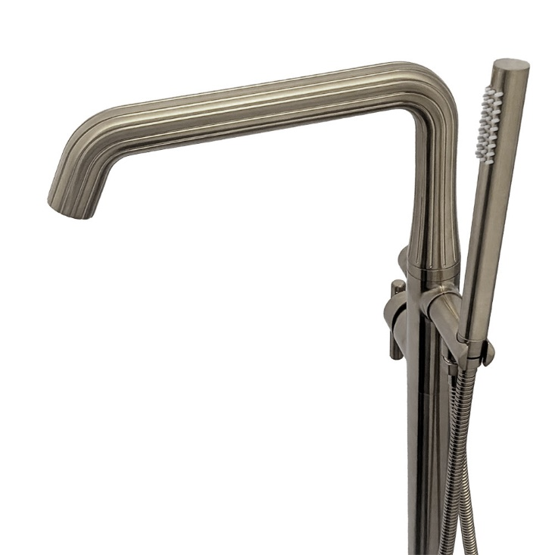
  Brushed nickel with flutes
  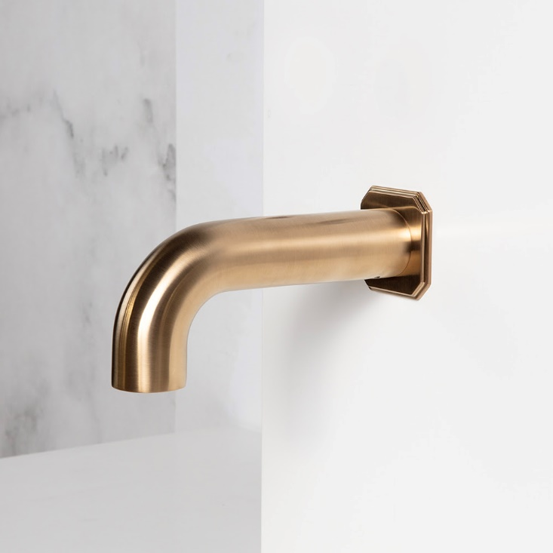
  Brushed bronze

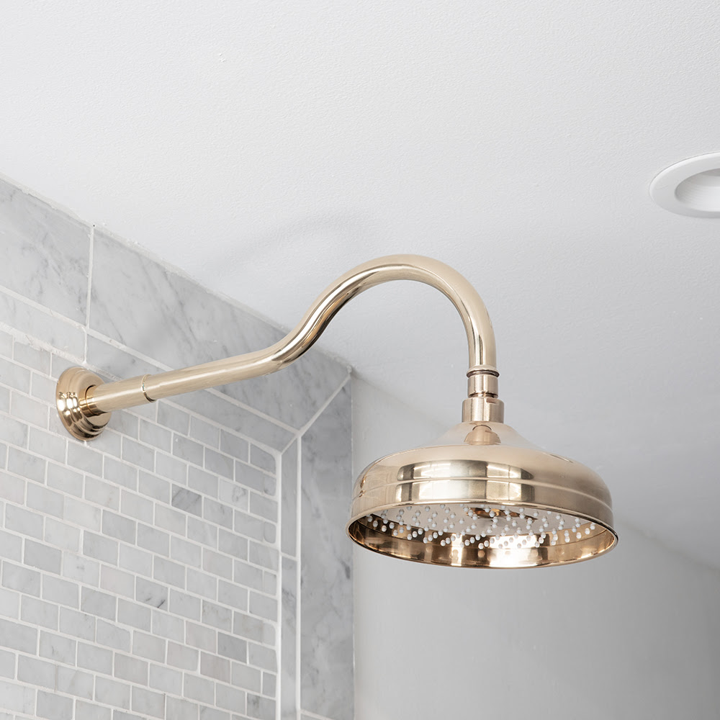

Polished bronze, available in 6" and 8" diam.

