

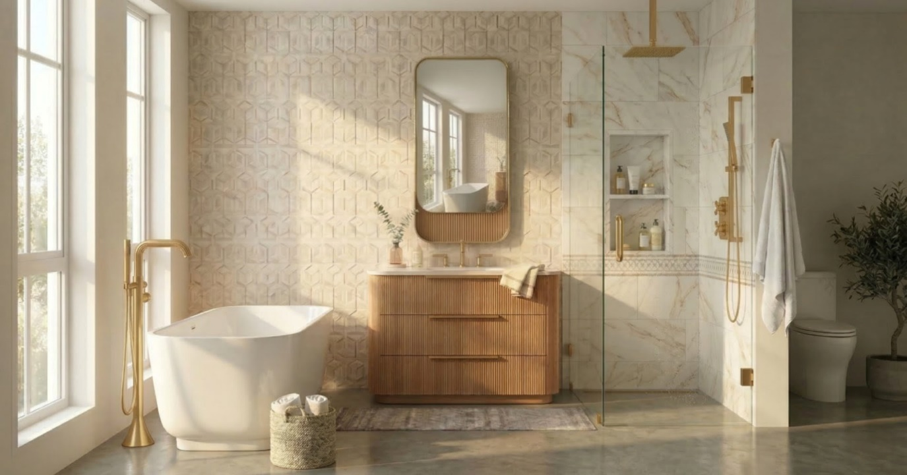

Glamour of the Past Into the Future

Goldenshire is a masterclass in transitional tension - this collection marries the architectural rhythm of contemporary, stain-washed wood with the soul of heirloom traditionalism of the tambour decorative surface. The seamless, soft-radius corners soften the linear texture, while the simple linear pulls act as a bridge grounding the modern silhouette in history. It’s a collection that explores the concept of soft geometry and simultaneously feels both modern and retro.

Shown: Goldenshire 36" vanity in natural oak tambour

EXPLORE THE GOLDENSHIRE COLLECTION



24-36" SINGLE OPTIONS

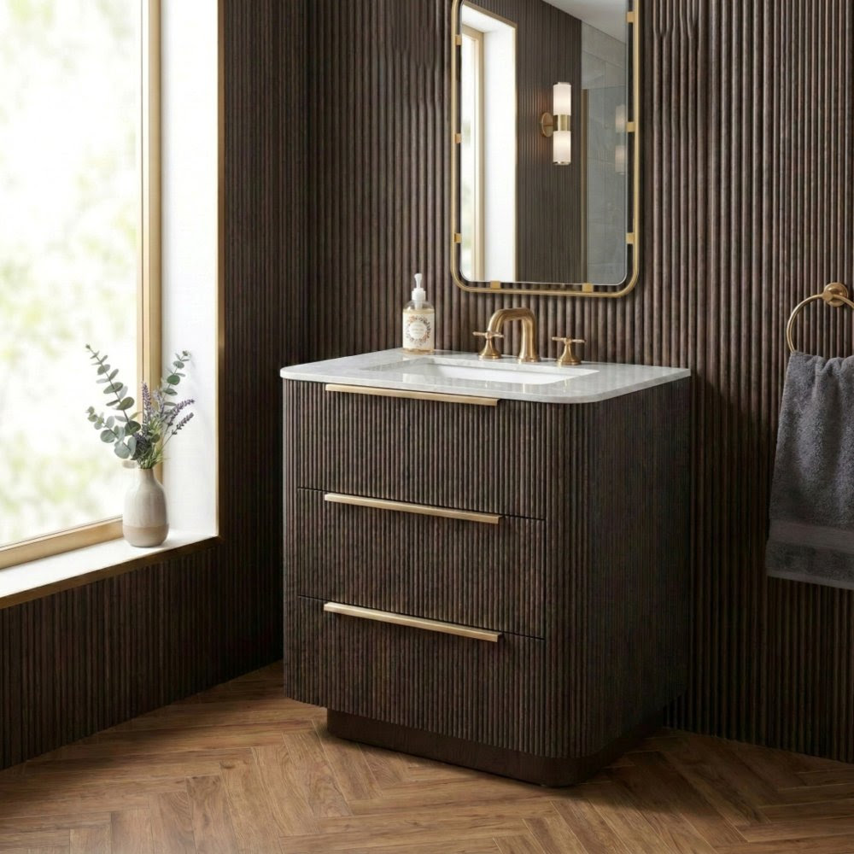

The Goldenshire Collection - proudly handmade in the USA - redefines bathroom elegance with its distinctive rounded corners and tambour, fluted, or smooth wood bases. This versatile series offers floor-standing and wall-mounted vanities ranging from 24" to 72", with high-end countertops in solid surface, natural stone, or quartz. Available in standard, premium, and luxury wood finishes, as well as an exlusive range of select finishes on the tambour and fluted panelling, each unit arrives fully equipped with soft-close drawers and pre-installed pulls for a seamless blend of style and functionality.

  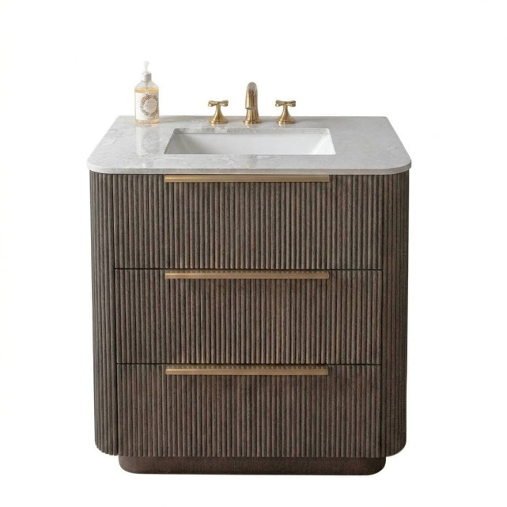
  30" in black oak tambour
  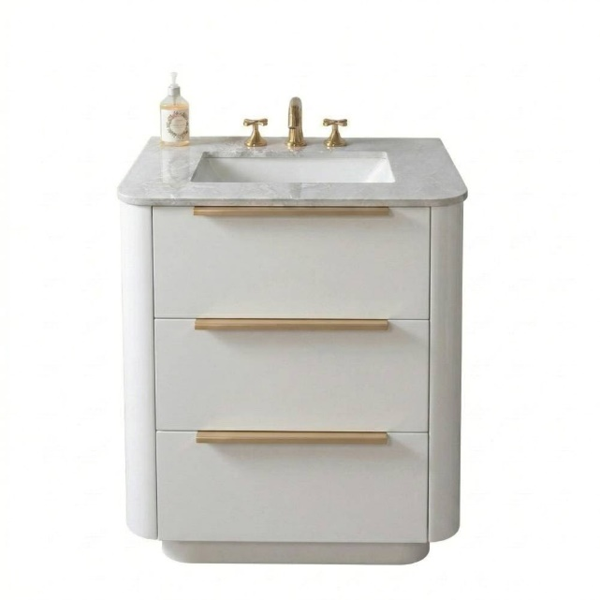
  24" in matte white

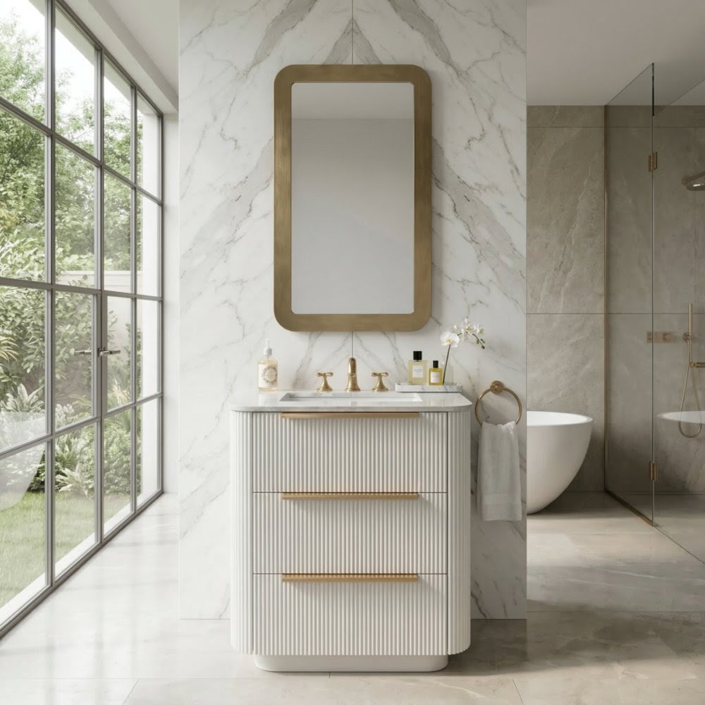

48"+ SINGLE & DOUBLE OPTIONS

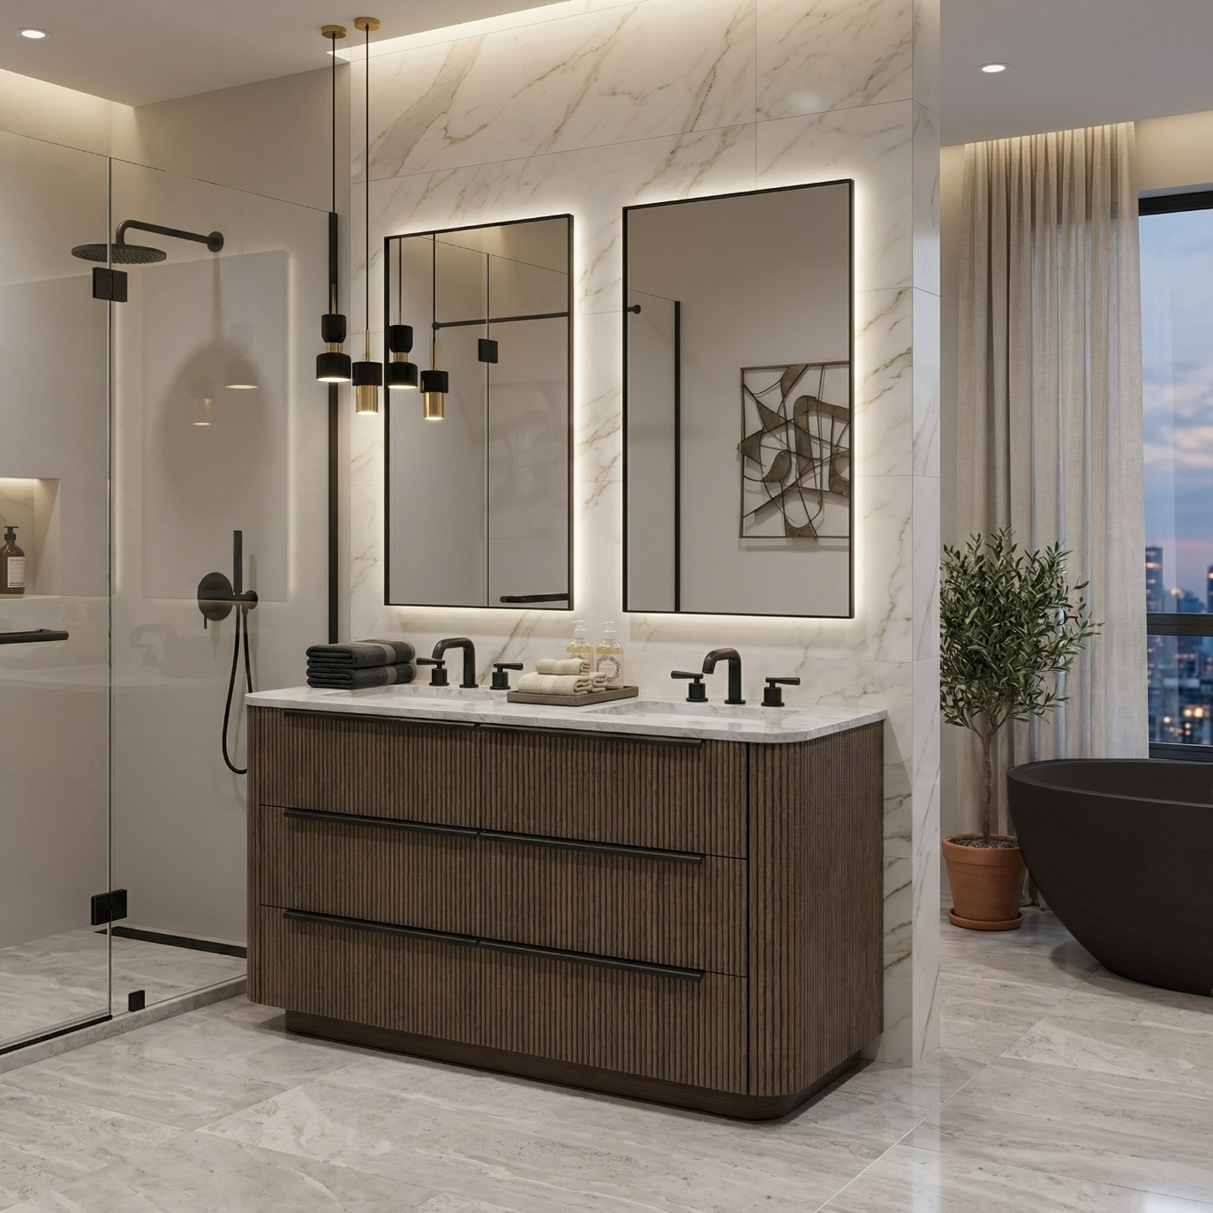

48" in coffee oak

Clad in a deeply saturated, toned oak, the vanities feature continuous vertical fluting that wraps effortlessly around curved edges, eliminating harsh lines. The visual weight of the continuous wood is offset by the simple outline of the modern hardware available in many finishes, creating a tactile experience that demands to be touched.

  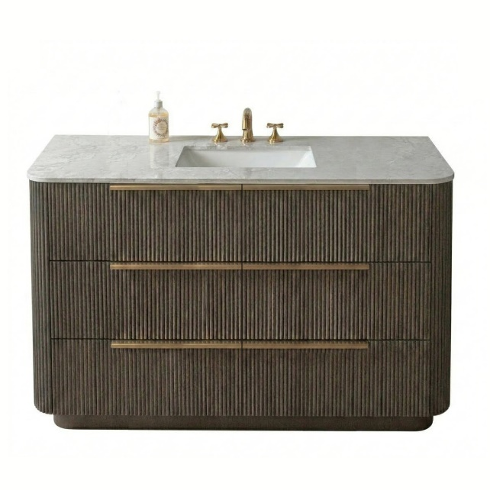
  48" in black oak tambour
  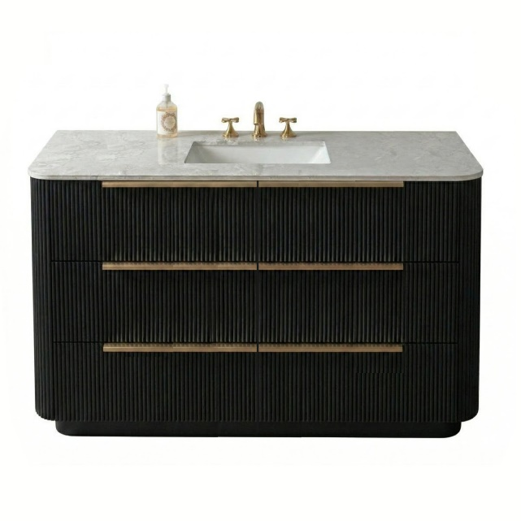
  48" in matte black tambour

60" SINGLE & DOUBLE

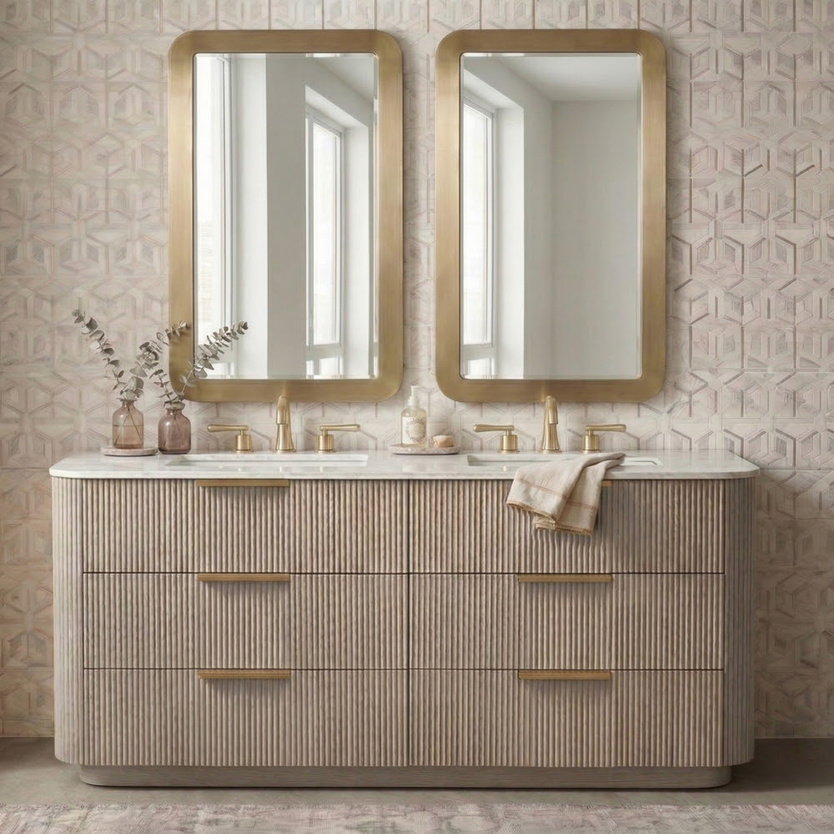

60" in grigio oak tambour

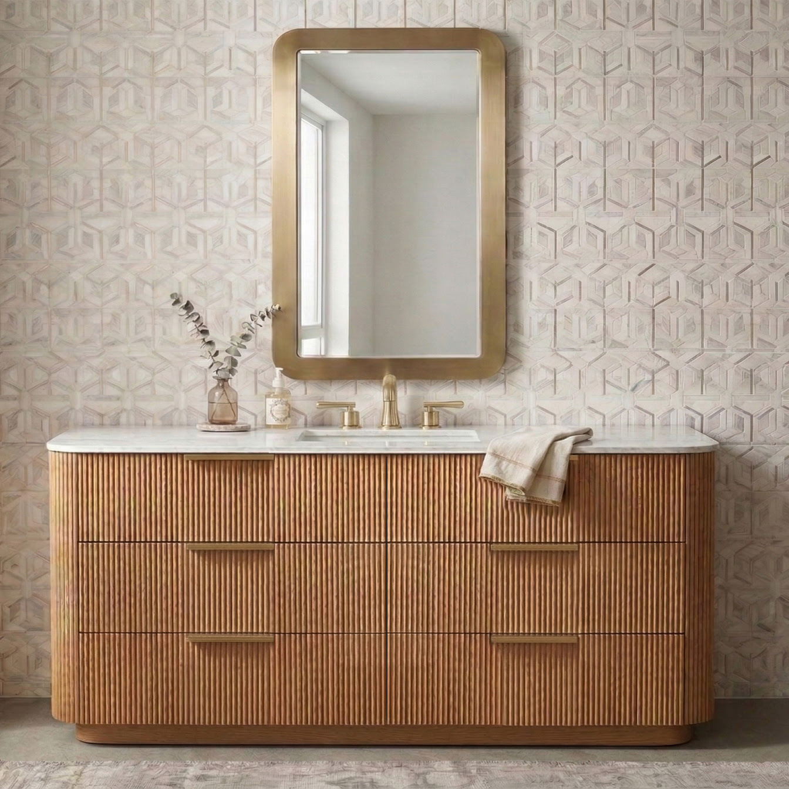

60" in natural oak tambour

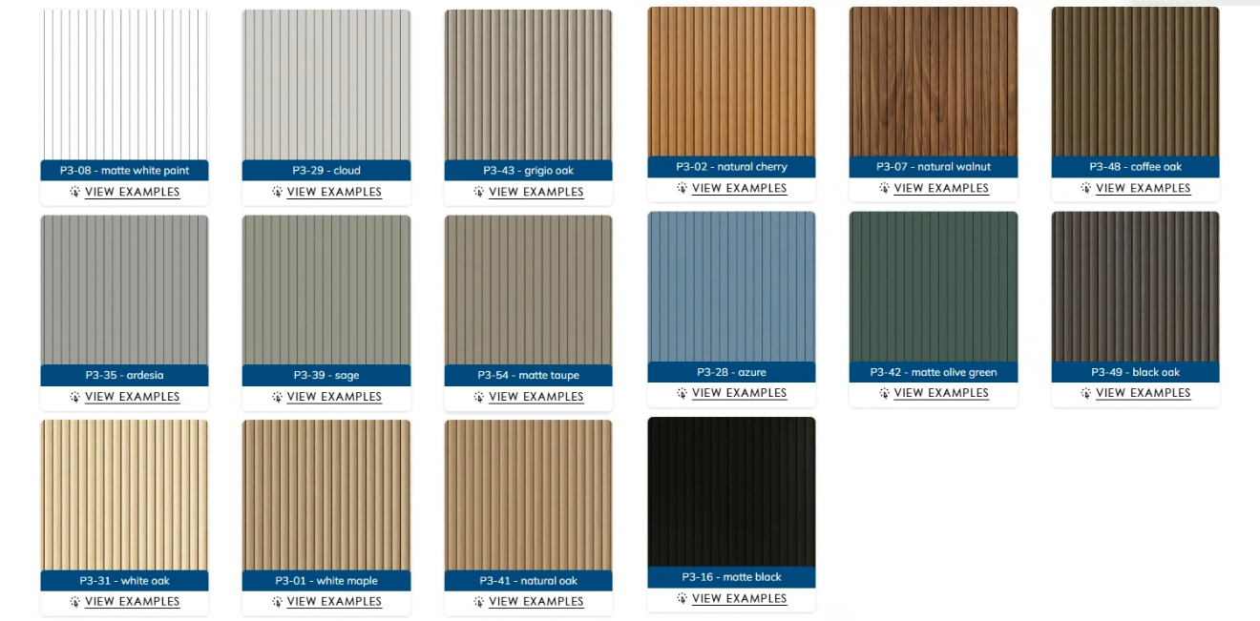

EXPLORE ALL FINISHES

