New Release · Spring 2026
Three New
Collections
We’re proud to introduce The Dover, The Stamford, and The Bedford: three distinct vanity designs crafted to bring character and refinement to the modern bathroom.
View on Configurator
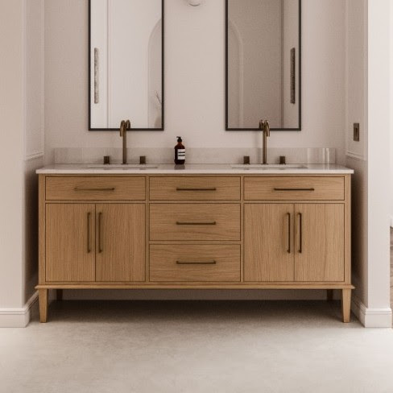 | New Collection  The Dover  Furniture-style craftsmanship elevated for the bathroom. The Dover rests on wood legs, including our new tapered option, with a clean door/drawer layout, blending transitional warmth with a contemporary silhouette.  Explore The Dover

New Collection  The Stamford  Quietly refined and grounded in presence. The Stamford’s gently curved edges and rounded detailing bring softness to the bathroom without sacrificing substance.  Explore The Stamford | 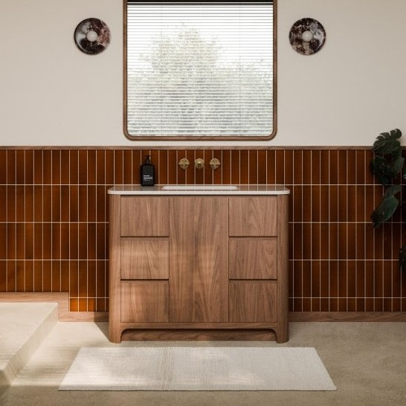

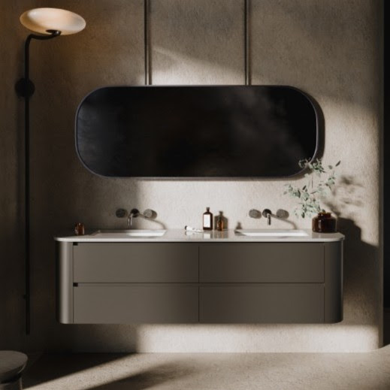 | New Collection  The Bedford  Wall-hung and architecturally bold. The Bedford’s sweeping wide curve and floating form make it a statement piece designed for the modern bathroom. Refined in detail, confident in presence.  Explore The Bedford

Elevate Your Space
Upgrade Options
Complete your vanity with premium additions designed to complement every collection.
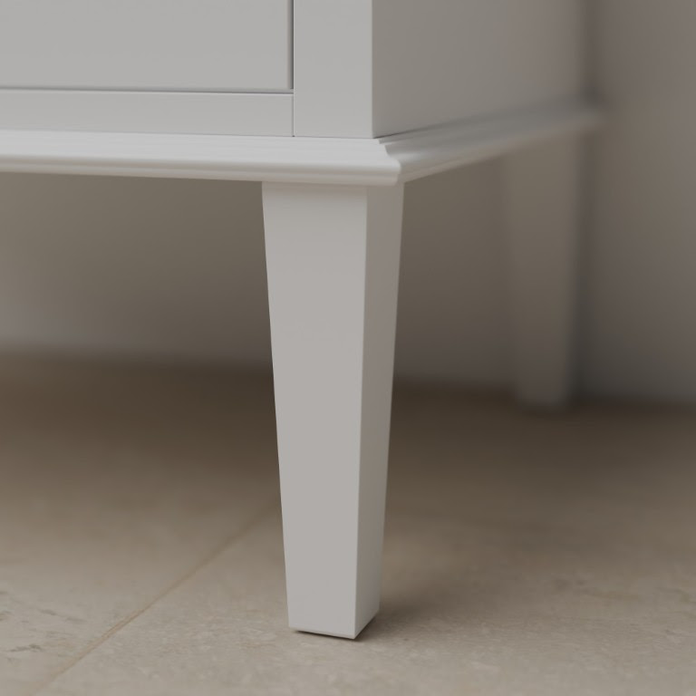 | New Option  Tapered Legs  By popular request, a new tapered leg option is here for both the Chester and the Dover, offering a beautiful transitional look to one of our best-selling vanity styles.  Configure it

Upgrade Option  Glass Drawer Dividers  Add a luxury feeling storage option with our new Glass Drawer Dividers.  Configure it | 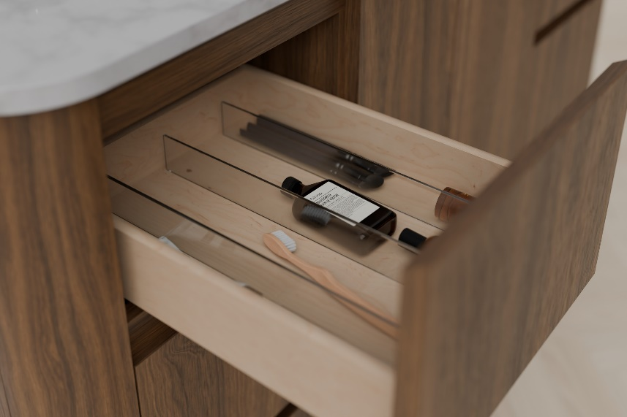

 | Upgrade Option  In-Countertop Charging  New FreePower Upgrade, Add Seamless Wireless Charging to your Vanity Top. Integrate a spot for you to charge your phone.  Configure it

Ready to transform
your bathroom?
Visit our website to see these designs on our configurator.
View on Configurator

