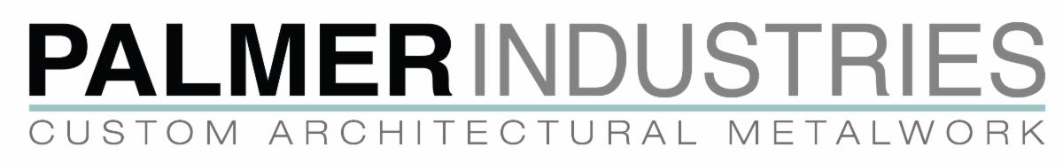

Dear Valued Dealer,

I hope this message finds you well.

Palmer is pleased to announce the release of our updated and improved Sinklegs 2025 Interactive Catalog & Price Book.

The good news is that Palmer’s prices have not changed…
However, our shipping costs have increased to reflect the new UPS rates, which become effective today.

We understand that any modifications in shipping prices can affect your planning and operations, and our team is fully committed to supporting you through these changes.
Whether you have questions about the new shipping prices, wish to discuss upcoming projects, or need assistance with any purchases, we are here to help.

We sincerely appreciate your understanding and continued partnership. Thank you for choosing Palmer Industries. Our dedication to providing exceptional products and service remains unwavering, and we look forward to continuing to serve you with quality craftsmanship in 2025.

Wishing you Happy Holidays and a prosperous New Year,

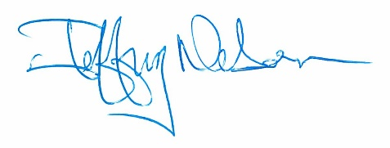

Jeffrey Nelson, CEO
Palmer Industries, Inc.
Warwick, RI 02888 USA
www.palmerindustries.com
(401) 421-1730

