*How to claim the FREE CM 5300 with Miele Dishwasher Purchase*
-Dishwasher must be purchased between Aug 26th – Sept 15th
-Rebate must be claimed online AND Miele dishwasher must be delivered by Oct 31st
-Please allow at least 8 weeks following submission of an executed redemption form for delivery of your Free CM 5300

Step 1: Follow Link - Buy a Dishwasher, Get a Free Coffee Machine | Miele (mieleusa.com)
Step 2: Scroll to bottom of page and click on “Claim Gift” (orange button)
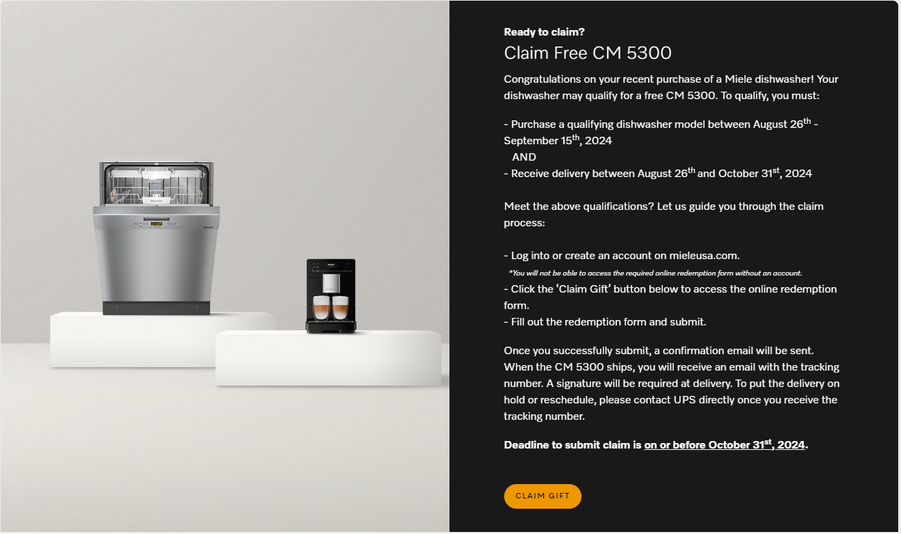

Step 3: Login or Register (create an account)
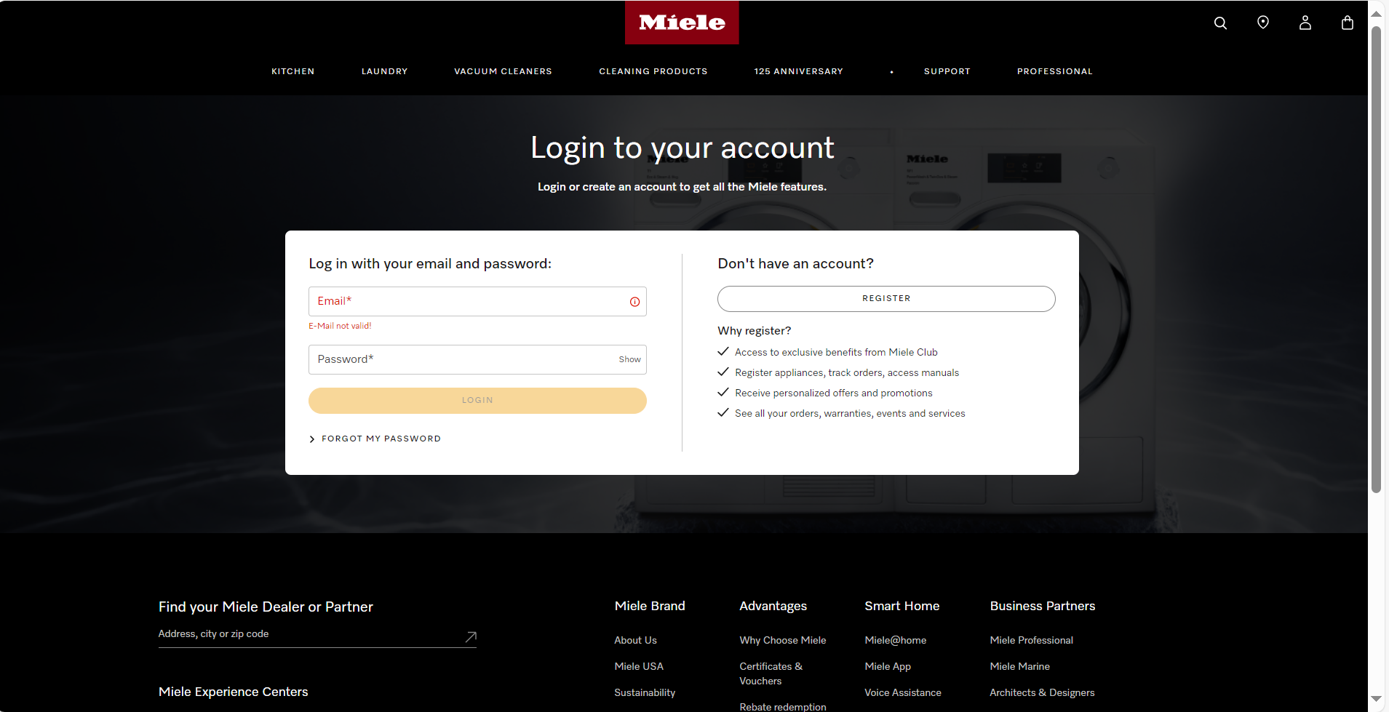
Step 4: Complete requirements in yellow; Enter in serial # of dishwasher, purchase date, and upload proof of purchase (at UMRP pricing). Then click “Redeem Voucher”
