This letter is to inform you that ThermaSol will be discontinuing the Signature Series Control as of Monday, January 15, 2024.
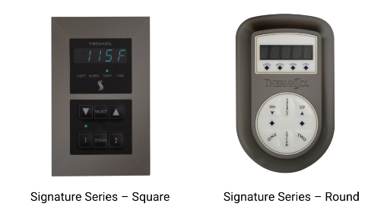
Our intent is to allow orders for these parts until stock is depleted in order to allow for future planning by our customers. For suggested replacements, please see chart below.
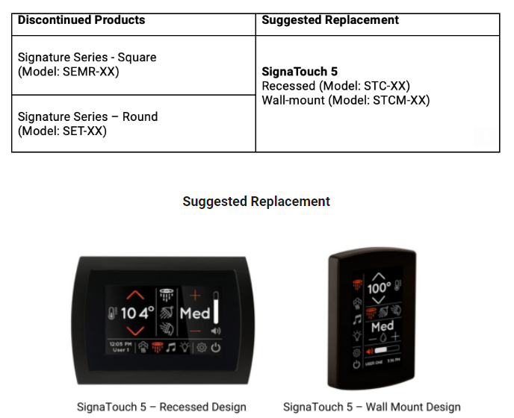
ThermaSol appreciates and values your business and looks forward to your continued support as we introduce innovative and original products throughout 2024.

