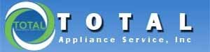

Appliance Repair in Northeast Ohio

(440) 526-2544 Cleveland, OH
service@totalappliance.com Email

Cleveland Address:

8080 Broadview Road
Broadview Heights, OH 44147
440-218-8311 Text

Hours of Operation:

Mon – Fri 8:30 am – 5:30 pm
Sat 8:30 am –12:00 pm
Sun Closed

Total Appliance is the ONLY factory certified service for Sub-Zero and Wolf in NE Ohio and Pittsburgh, PA. They also provide quality service for other major brands.

Coverage Areas:

Nearly all of Northeast Ohio: Cleveland Metropolitan, Elyria to Painesville, Akron and most of

BRANDS:

Bosch | Fisher & Paykel/DCS | Maytag | Thermador
Broan/Best | Frigidaire | Peerless Premier | True
Cove | Gaggenau | Scotsman | ULine
Dacor | GE/Haier | Sharp | Viking
DCS | JennAir | SpeedQueen | Whirlpool
Electrolux | KitchenAid | SubZero | Wolf
Faber | Marvel | Tappan | Zephyr
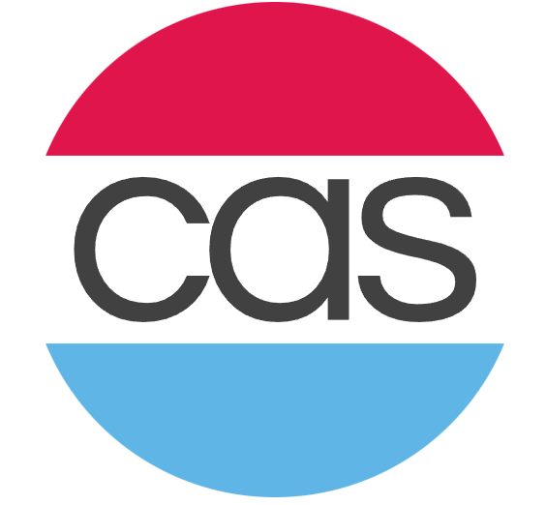 COMPLETE APPLIANCE SERVICE

4735 Richmond Rd.
Warrensville Heights, Ohio 44128
216-364-2700 Phone

Business Hours
Monday - Friday: 8:00AM - 5:30PM
Saturday: Shop is closed indefinitely, however office hours vary –
Sunday: Closed (Except for Emergency Advice)
Emergency Service: Yes

Service Coverage Area: Area Codes: 216, 234, 330 & 440

BRANDS: *Services brands marked with an asterisk, but no longer accepts warranty work for those brands.

AGA | Elica | KitchenAid | Smeg
Amana | Euro Cave | La Cornue | Speed Queen
Asko | Faber | LG | Sub-Zero
Aventi | Fisher & Paykel | Magic Chef | Summit
Bertazzoni | Friedrich | Marvel | Tappan
Blomberg | Frigidaire | Maytag | Thermador
Blue Star | Fulgor | Midea Group | Thor
Bosch | Gaggenau Hausgerate | Miele | U-Line
Broan | GE | Monogram | Verona
Capital | Gibson | Peerless-Premier | Viking
Cosmo | Haier | Perlick | Whirlpool
Dacor | Hotpoint | Roper | White-Westinghouse
Danby | InSinkErator | Samsung | Wine Enthusiast
DCS* | Jenn-Air | Scotsman | Wolf*
EdgeStar | Kelvinator | Sharp | Zephyr*
Electrolux | Kenmore | Siemens | ZLINE
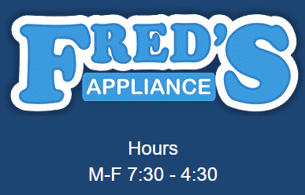

1949 Hubbard Road
Madison, OH 44057
www.fredsappliance.com

Text or Call: 330-356-5205

Service Area: Northeast Cleveland Area in 6 Counties
Does not offer emergency service, but has same day service depending up

BRANDS: WHIRLPOOL
MAYTAG
KITCHEN-AID
AMANA
GE

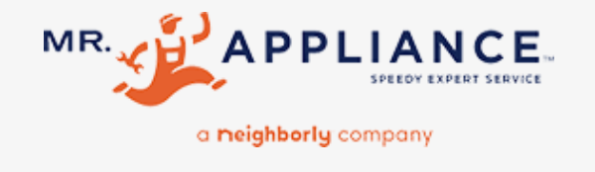

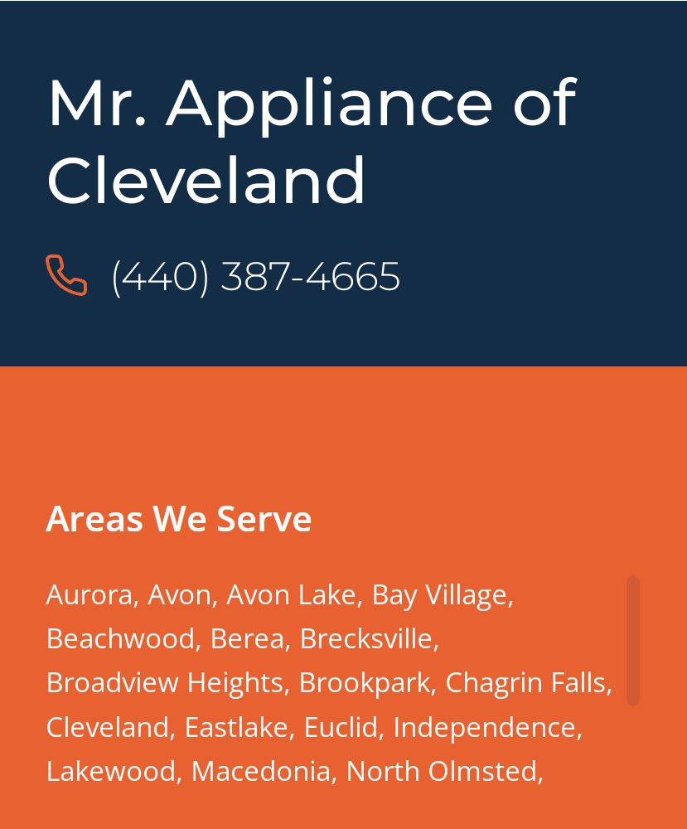

4734 Spring Road
Brooklyn Heights, OH 44131
www.mrappliance.com

Brands We Serve
- Amana Fulgor (FCI) Panasonic
- Asko Gaggenau Samsung
- Bosch GE Monogram Sanyo
- Dacor General Electric Sharp
- Danby Haier SubZero
- DCS by Fisher & Paykel Hotpoint Thermador
- Electrolux JennAir Viking
- Elmira Kenmore Westinghouse
- Equator LG Whirlpool
- Faber Range Hoods Marvel Wine Guardian
- Fisher & Paykel Maytag Wolf
- Frigidaire Miele Zephyr

3879 State Road
Cuyahoga Falls, OH 44223
330-752-6751
330-422-4529
www.protecrepair.com

Service Area: Cleveland, Akron, Canton

Hours: Mon – Fri 9:00 am – 5:00 pm

Also performs extended warranty repairs

Residential Appliances
Commercial Appliances

Refrigerators Ranges

Dishwashers Washing Machines

Microwaves Dryers

Ovens Wine Coolers

Cooktops Dehumidifiers & more…

SELECT BRANDS:

Bosch Haier
Electrolux Midea
Frigidaire Miele
GE Samsung
LG Speed Queen
+ more

