
ANNOUNCEMENT

Date: January 24th, 2023

Re: BLANCO Shipment Notification

Dear valued customers,
Our primary goal at BLANCO is to build brand loyalty with our customers by providing a premium experience, and ultimately making life easier in the kitchen.
Based on your valued feedback and our goal to provide an improved experience for our customers, we are pleased to announce the launch of automated Shipment Notifications for all orders shipped prepaid or prepaid & charge from our US and Canadian warehouses. These notifications will be sent to the same individual that receives the order confirmations and will provide visibility to the order number and items in the shipment, as well as a live link to the Tracking number. By taking this proactive initiative, we eliminate the need for our customers to reach out to BLANCO Customer Care for this information.

Below is an example of a shipment notification. The PO#, SKUs and quantities shipped are located under ‘Additional Shipper Message’.
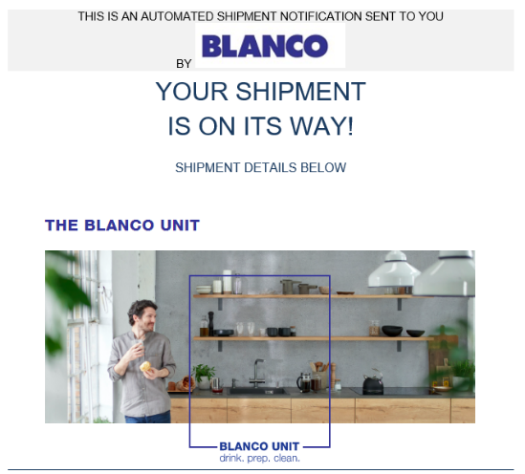
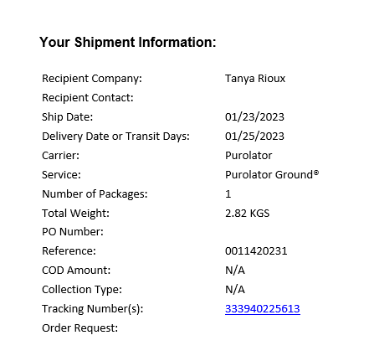
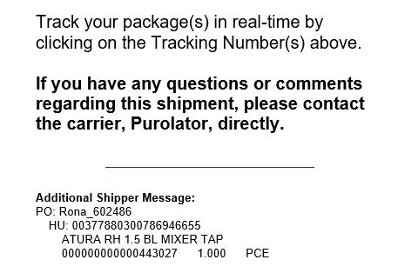

BLANCO is excited to share this announcement, as it moves us forward in our journey to improve the customer experience.

We thank you for your ongoing support and welcome your continued feedback.

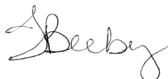
Tracy Beeby
Customer Care Manager, NA

