BLANCO America Holiday Schedule

Please see below our Inventory and Holiday schedule for the 2021 Season.
Please contact me if you have any questions or concerns.
Thanks,
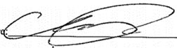
Chrissy Kasap
Inside Sales Specialist

