

DATE - JULY 13 THUR AUG 10TH

DISCOUNT - ADDITIONAL 10% OFF ALL PARABOLA SALES

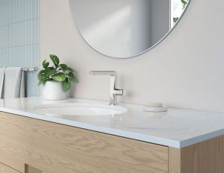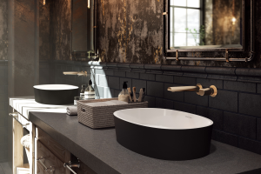

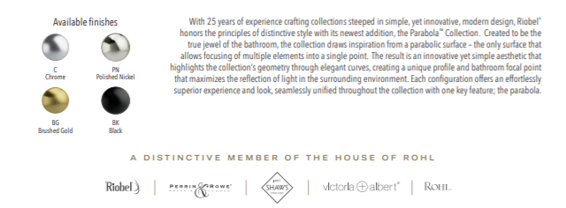

Feel free to add to your regular Riobel order with special discount on the Parabola items.

