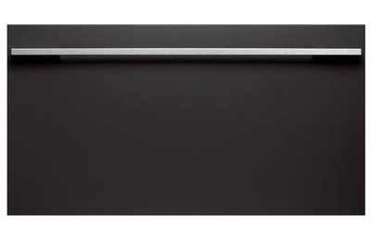
Fisher & Paykel Cool Drawer Multi-Temperature Drawer

34”
3.1 cu. ft. Capacity
5 Temperature Settings
Sabbath Mode

Sale: $1,999.00
List: $2,309.00

Location: Bedford Heights
Model number: RB36S25MKIW1
EPS: 472693

SubZero 36” Tall Refrigerator w/Internal Dispenser

Panel Ready

Sale: $6,999.00
List: $8,310.00

Location: Bedford Heights
Model number: IT-36RID-LH
EPS: 704876

SubZero 24” Undercounter Refrigerator

Stainless Steel

Sale: $2,399.00
List: $2,761.00

Location: Bedford Heights
Model number: UC-24RO/PH-LH
EPS: 458679

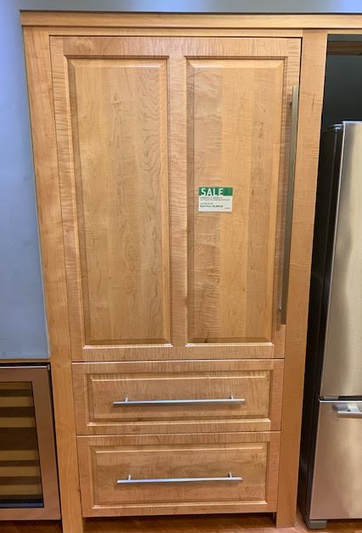

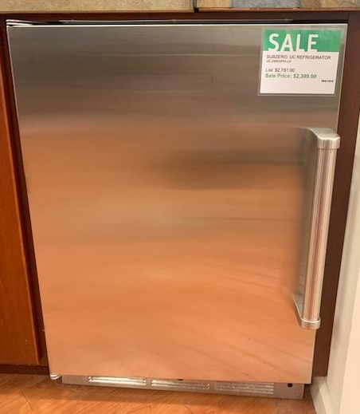

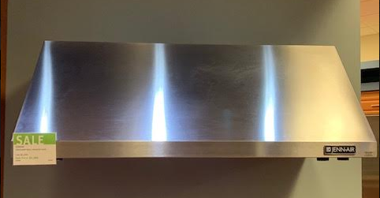
Jennair Wall Mount Hood

Stainless Steel

Sale: $1,399.00
List: $2,399.00

Location: Bedford Heights
Model number: JXW9048WP
EPS: 1231997

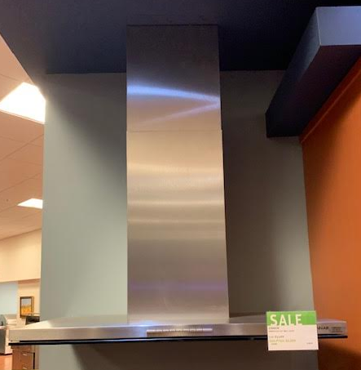
Jennair 36” Wall Hood

Stainless Steel

Sale: $2,299.00
List: $3,499.00

Location: Bedford Heights
Model number: JXW8936DS
EPS: 1231994

Miele 36” Wall Hood

Stainless Steel

Sale: $1,599.00
List: $2,149.00

Location: Bedford Heights
Model number: DA5391W
EPS: 470244

Custom Ventahood

60” Custom Hood w/Satin Brass Lip Treatments
900CFM w/Duct Cover

Sale: $5,000.00
List: $8,0299.00

Location: Bedford Heights
Model number:
EPS:

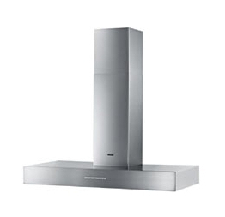

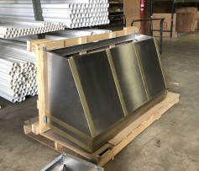

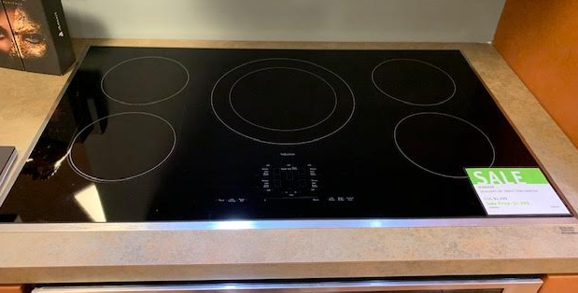
Jennair 36” Induction Cooktop

Sale: $1,399.00
List: $2,299.00

Location: Bedford Heights
Model number: JIC4536X5
EPS: 1231943

Bosch 36” Induction Cooktop

Sale: $1,799.00
List: $2,299.00

Location: Bedford Heights
Model number: NIT8666UC
EPS: 871911

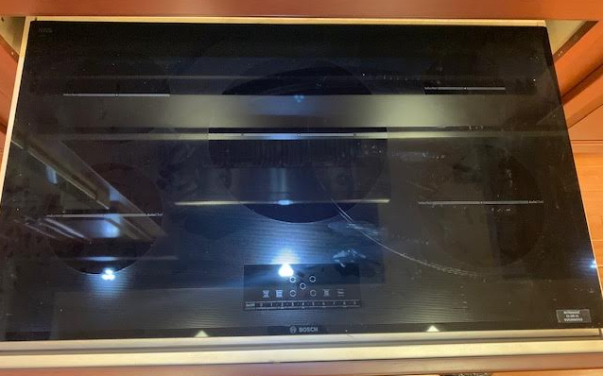

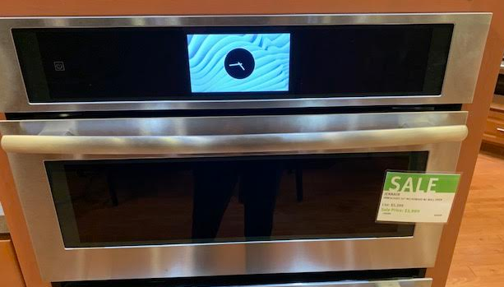
Jennair 30” Microwave w/Wall Oven

Sale: $3,999.00
List: $5,399.00

Location: Bedford Heights
Model number: JMW3430DS
EPS: 1231931

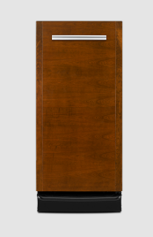
Jennair 15” Trash Compactor

Sale: $599.00
List: $1,399.00

Location: Bedford Heights
Model number: TC607

