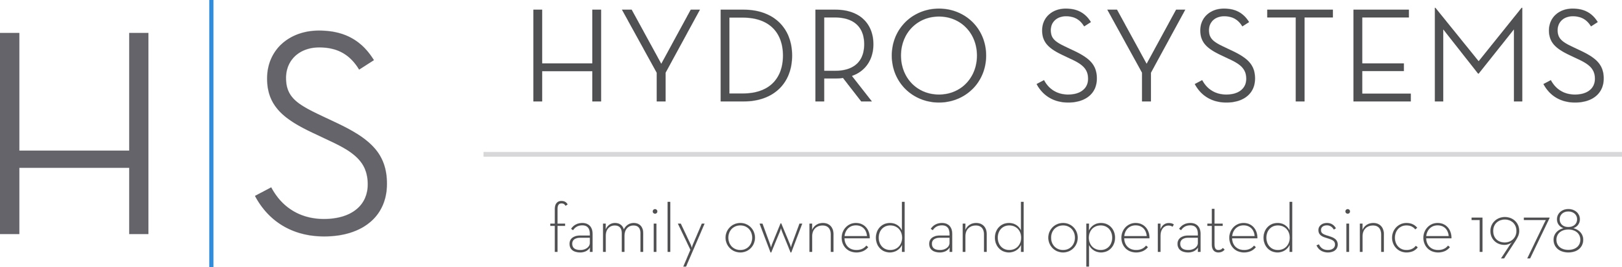

Hydro Systems Winter Promotion 2019 – Details

- Promotion runs December 1, 2019 – March 31, 2020. Eligibility based on date of purchase order sent to Hydro Systems.

- All Designer Collection bathtubs are eligible for this promotion. Promotion does not apply to: Metro, Studio, and STON bathtubs.

- Any customer that purchases a Designer collection soaking tub can choose up to 2 of the following options, at no charge to consumer:
  - Extra high density
  - Linear integral waste and overflow
  - Micro mount (available only with drop-in models)

- Any customer that purchases a Designer collection whirlpool, thermal air, or combo system can choose up to 4 of the following options, at no charge to consumer:
  - Extra high density
  - Hydro Fusion (available with any system tub)
  - 750-Watt Inline Heater (available only with whirlpool or combo systems)
  - LED lighting
  - Linear integral waste and overflow
  - Micro mount (available only with drop-in models)

- This promotion cannot be combined with any other offer/rebate

- No substitutions are allowed when selecting options for promotion

- Must enter promo code: WINTERPROMO for sale to be eligible for promotion

- Fill out purchase order with normal pricing for options and we will not charge for those options when your bill is sent.

