 Humidor Summer Savings
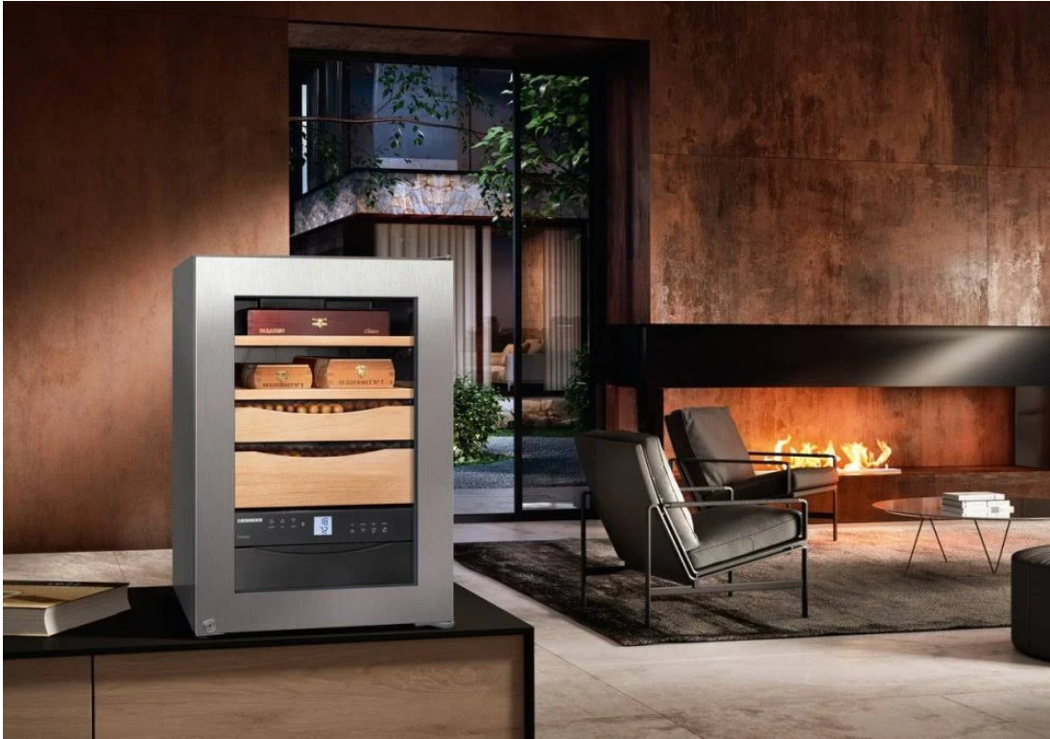
MSRP | Sale
$1999 | $1799
