August 27, 2018

To: Baldwin Customers
Re: Estate 4308 Crystal Cabinet Knob

Dear Baldwin Customer,

Effective immediately, we will be discontinuing the 4308 crystal cabinet knob in all finishes, and any orders in the system will need to be canceled. Baldwin prides itself on producing high quality products, and unfortunately the 4308 knob can no longer consistently perform to our quality standards so we are removing it from the portfolio. If you have an open order containing the affected product please contact Baldwin Hardware at (800)-437-7448. We apologize for any inconvenience.

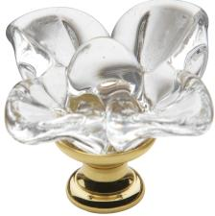
4308 Pictured Knob
SKUs Affected:
- 4308.030
- 4308.112
- 4308.150
- 4308.260

Thank you for your support.

Regards,

Kevin Bean,
Baldwin Director of Marketing

