2018 STONE FOREST NEW DESIGNS

CODE DESCRIPTION COLOR PRICE
TD-VSL-REC AGL TD-VSL-REC CA
CONTOUR VESSEL, RECTANGLE CONTOUR VESSEL, RECTANGLE
ANTIQUE GRAY LIMESTONE CARRARA MARBLE
1250
1400
DIMS: 24"W x 15"D x 5"H WEIGHT APPROX 50LBS

TD-VSL-RND AGL TD-VSL-RND CA

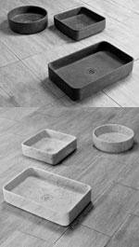CONTOUR VESSEL, ROUND CONTOUR VESSEL, ROUND

ANTIQUE GRAY LIMESTONE CARRARA MARBLE

1040
1130

DIMS: 16"DIAM x 5"H WEIGHT APPROX 35LBS

TD-VSL-SQR AGL TD-VSL-SQR CA

CONTOUR VESSEL, SQUARE CONTOUR VESSEL, SQUARE

ANTIQUE GRAY LIMESTONE CARRARA MARBLE

1050
1150

DIMS: 16"W x 16"D x 5"H WEIGHT APPROX 35LBS

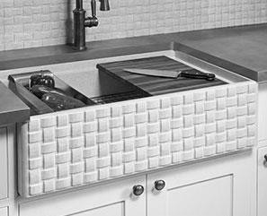C04-BSKT-KP PA WORKSTATION KITCH SINK BASKET WEAVE PATTERN APRON
PAPIRO CREAM MARBLE 3150

DIMS: 33"W x 21"D x 10"H WEIGHT APPROX 330LBS

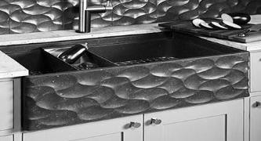C04-CNC-KP NB WORKSTATION KITCH SINK WAVE FRONT PATTERN APRON
NOCE BASALT 3250

DIMS: 33"W x 21"D x 10"H WEIGHT APPROX 330LBS

LKP-210068 MP LKP-210067 WT
CUTTING BOARD CUTTING BOARD
MAPLE WALNUT
260
260
DIMS: 12"W x 19"L x 1.5"H WEIGHT APPROX 5LBS

LKP-205334 MP LKP-205234 WT
STAINLESS TRAY STAINLESS TRAY
MAPLE WALNUT
265
265
DIMS: 12"W x 19"L x 2.25"H WEIGHT APPROX 5LBS

LKP-215308 MP LKP-215208 WT
DRYING RACK DRYING RACK
MAPLE WALNUT
280
280
DIMS: 12"W x 19"L x 1"H WEIGHT APPROX 5LBS

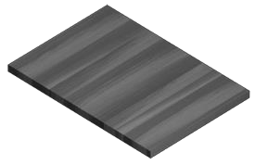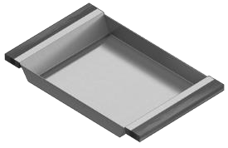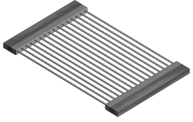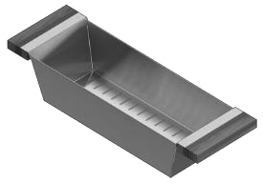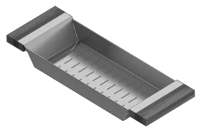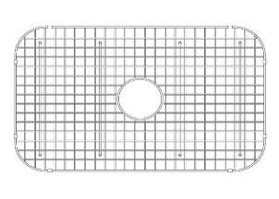LKP-205325 MP LKP-205225 WT
STAINLESS COLANDER, DEEP STAINLESS COLANDER, DEEP
MAPLE WALNUT
245
245
DIMS: 6"W x 19"L x 4.25"H WEIGHT APPROX 5LBS

LKP-205319 MP LKP-205219 WT
STAINLESS COLANDER, SHALLOW STAINLESS COLANDER, SHALLOW
MAPLE WALNUT
220
220
DIMS: 6"W x 19"L x 2.25"H WEIGHT APPROX 5LBS

SG-33-KP STAINLESS GRID STAINLESS STEEL 310
310
DIMS: 29.5"W x 17.5"L x 1"H
FITS SINGLE BASIN MODELS: C04-BSKT-KP AND C04-CNC-KP
WEIGHT APPROX 15LBS

NOTE: Product codes starting with D, G, L and W have a different discount structure. Please contact us or your representative for more information.

Stone Forest recommends and warranties our stone kitchen sinks only when used with waste disposers 3/4 HP or less. Warranty does not cover damage to product caused by improper installation. See website for installation guidelines.

VERGE™ is a collection of brass legs with knurled fittings supporting any combination of stone, wood and steel components. This unique modular concept allows you to combine integral stone sinks, wood drawers and steel or wood shelving in unlimited combinations to create bath consoles and stand-alone storage systems. Brass legs and fittings available in either aged brass or polished nickel.

CODE DESCRIPTION COLOR PRICE
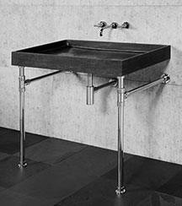TD-THN-36 AGL
+PFS-TDST PN
TD-THN-36 AGL
+PFS-TDST AB
TD-THN-36 CA
+PFS-TDST PN
TD-THN-36 CA
+PFS-TDST AB

VERGE BATH VANITY, 36W

INCLUDES: VERGE 2 LEG STAND VERGE BATH SINK
ANTIQUE GRAY LIMESTONE POLISHED NICKEL

ANTIQUE GRAY LIMESTONE POLISHED NICKEL

CARRARA MARBLE POLISHED NICKEL

CARRARA MARBLE AGED BRASS
3150

3010

3450

3310
DIMS: 36"W x 22"D x 36"H WEIGHT APPROX 120LBS
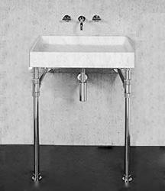TD-THN-24 AGL
+PFS-TDST PN
TD-THN-24 AGL
+PFS-TDST AB
TD-THN-24 CA
+PFS-TDST PN
TD-THN-24 CA
+PFS-TDST AB

VERGE BATH VANITY, 24W

INCLUDES: VERGE 2 LEG STAND VERGE BATH SINK
ANTIQUE GRAY LIMESTONE POLISHED NICKEL

ANTIQUE GRAY LIMESTONE AGED BRASS

CARRARA MARBLE POLISHED NICKEL

CARRARA MARBLE AGED BRASS
2875

2735

3090

2950
DIMS: 24"W x 22"D x 36"H WEIGHT APPROX 100LBS
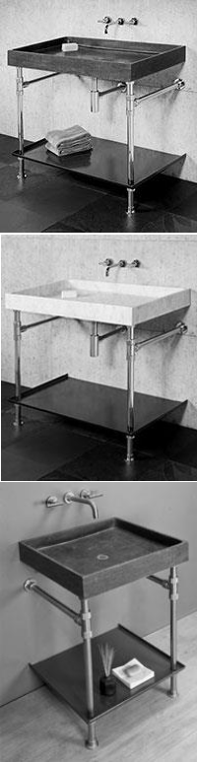TD-THN-36 AGL
+PFS-TDTRY-36 PN

TD-THN-36 AGL
+PFS-TDTRY-36 AB

TD-THN-36 CA
+PFS-TDTRY-36 PN

TD-THN-36 CA
+PFS-TDTRY-36 AB

VERGE BATH VANITY, 36W WITH FOLDED METAL TRAY

INCLUDES: VERGE BATH SINK VERGE 2 LEG STAND FOLDED METAL TRAY

ANTIQUE GRAY LIMESTONE POLISHED NICKEL
TUXEDO GRAY METAL

ANTIQUE GRAY LIMESTONE AGED BRASS
TUXEDO GRAY METAL

CARRARA MARBLE POLISHED NICKEL TUXEDO GRAY METAL
CARRARA MARBLE AGED BRASS
TUXEDO GRAY METAL

3884

3730

4184

4030

DIMS: 36"W x 22"D x 36"H WEIGHT APPROX 100LBS

TD-THN-24 AGL
+PFS-TD-TRY-24 PN

TD-THN-24 AGL
+PFS-TD-TRY-24 AB

TD-THN-24 CA
+PFS-TD-TRY-24 PN

TD-THN-24 CA
+PFS-TD-TRY-24 AB

VERGE BATH VANITY, 24W WITH FOLDED METAL TRAY

INCLUDES: VERGE BATH SINK VERGE 2 LEG STAND FOLDED METAL TRAY

ANTIQUE GRAY LIMESTONE POLISHED NICKEL
TUXEDO GRAY METAL

ANTIQUE GRAY LIMESTONE AGED BRASS
TUXEDO GRAY METAL

CARRARA MARBLE POLISHED NICKEL TUXEDO GRAY METAL

CARRARA MARBLE AGED BRASS
TUXEDO GRAY METAL

3569

3421

3784

3636

DIMS: 24"W x 22"D x 36"H WEIGHT APPROX 100LBS

TD-THN-36 AGL
+PFS-TSST AB
+PFS-STSLF-36 AGL TD-THN-36 AGL
+PFS-TSST PN
+PFS-STSLF-36 AGL TD-THN-36 AGL
+PFS-TSST AB
+PFS-STSLF-36 CA TD-THN-36 AGL
+PFS-TSST PN
+PFS-STSLF-36 CA

VERGE BATH VANITY, 36W WITH STONE SHELF

INCLUDES: VERGE BATH SINK VERGE 2 LEG STAND STONE SHELF
ANTIQUE GRAY LIMESTONE AGED BRASS

ANTIQUE GRAY LIMESTONE POLISHED NICKEL

CARRARA MARBLE AGED BRASS

CARRARA MARBLE POLISHED NICKEL
3758

3898

4158

4298
DIMS: 36"W x 22"D x 36"H
WEIGHT APPROX 100LBS
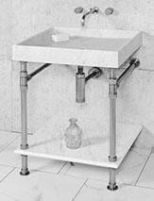TD-THN-24 AGL
+PFS-TSST AB
+PFS-STSLF-24 AGL TD-THN-24 AGL
+PFS-TSST PN
+PFS-STSLF-24 AGL TD-THN-24 AGL
+PFS-TSST AB
+PFS-STSLF-24 CA TD-THN-24 AGL
+PFS-TSST PN
+PFS-STSLF-24 CA

VERGE BATH VANITY, 24W WITH STONE SHELF

INCLUDES: VERGE BATH SINK VERGE 2 LEG STAND STONE SHELF
ANTIQUE GRAY LIMESTONE AGED BRASS

ANTIQUE GRAY LIMESTONE POLISHED NICKEL

CARRARA MARBLE AGED BRASS

CARRARA MARBLE POLISHED NICKEL
3403

3543

3708

3848
DIMS: 24"W x 22"D x 36"H
WEIGHT APPROX 100LBS
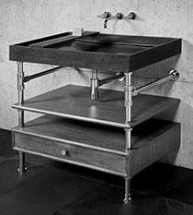TD-THN-36 AGL
+PFS-TDD6SLF-36 PN

TD-THN-36 AGL
+PFS-TDD6SLF-36 AB

TD-THN-36 CA
+PFS-TDD6SLF-36 PN

TD-THN-36 CA
+PFS-TDD6SLF-36 AB

VERGE BATH VANITY WITH STORAGE, 36W

INCLUDES: VERGE BATH SINK VERGE 2 LEG STAND (1) WOOD SHELF
(1) 6"D DRAWER

ANTIQUE GRAY LIMESTONE POLISHED NICKEL
CEMENT GRAY WOOD

ANTIQUE GRAY LIMESTONE AGED BRASS
CEMENT GRAY WOOD

CARRARA MARBLE POLISHED NICKEL CEMENT GRAY WOOD

CARRARA MARBLE AGED BRASS
CEMENT GRAY WOOD

4673

4513

4973

4813

DIMS: 36"W x 22"D x 36"H
WEIGHT APPROX 100LBS

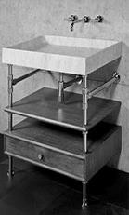TD-THN-24 AGL
+PFS-TDD6SLF-24 PN

TD-THN-24 AGL
+PFS-TDD6SLF-24 AB

TD-THN-24 CA
+PFS-TDD6SLF-24 PN

TD-THN-24 CA
+PFS-TDD6SLF-24 AB

VERGE BATH VANITY WITH STORAGE, 24W

INCLUDES: VERGE BATH SINK VERGE 2 LEG STAND (1) WOOD SHELF
(1) 6"D DRAWER

ANTIQUE GRAY LIMESTONE POLISHED NICKEL
CEMENT GRAY WOOD

ANTIQUE GRAY LIMESTONE AGED BRASS
CEMENT GRAY WOOD

CARRARA MARBLE POLISHED NICKEL CEMENT GRAY WOOD

CARRARA MARBLE AGED BRASS
CEMENT GRAY WOOD

4238

4078

4453

4293

DIMS: 24"W x 22"D x 36"H WEIGHT APPROX 100LBS

TD-THN-FCT-36 AGL
+PFS-TDD6SLFPNT-36 PN

TD-THN-FCT-36 AGL
+PFS-TDD6SLFPNT-36 AB

TD-THN-FCT-36 CA
+PFS-TDD6SLFPNT-36 PN

TD-THN-FCT-36 CA
+PFS-TDD6SLFPNT-36 AB

VERGE BATH VANITY WITH FAUCET DECK, 36W PAINTED STORAGE

INCLUDES:
VERGE BATH SINK (FAUCET MOUNT) VERGE 2 LEG CONSOLE
(1) WOOD SHELF (1) 6"D DRAWER
3 HOLE DRILLING

ANTIQUE GRAY LIMESTONE POLISHED NICKEL
PAINTED WOOD

ANTIQUE GRAY LIMESTONE AGED BRASS
PAINTED WOOD

CARRARA MARBLE POLISHED NICKEL PAINTED WOOD

CARRARA MARBLE AGED BRASS PAINTED WOOD

5098

4938

5398

5238

DIMS: 36"W x 22"D x 36"H WEIGHT APPROX 100LBS
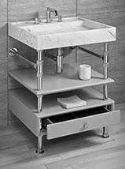TD-THN-FCT-24 AGL
+PFS-TDD6SLFPNT-24 PN

TD-THN-FCT-24 AGL
+PFS-TDD6SLFPNT-24 AB

TD-THN-FCT-24 CA
+PFS-TDD6SLFPNT-24 PN

TD-THN-FCT-24 CA
+PFS-TDD6SLFPNT-24 AB

VERGE BATH VANITY WITH FAUCET DECK, 36W PAINTED STORAGE

INCLUDES:
VERGE BATH SINK (FAUCET MOUNT) VERGE 2 LEG CONSOLE
(1) WOOD SHELF (1) 6"D DRAWER
3 HOLE DRILLING

ANTIQUE GRAY LIMESTONE POLISHED NICKEL
PAINTED WOOD

ANTIQUE GRAY LIMESTONE AGED BRASS
PAINTED WOOD

CARRARA MARBLE POLISHED NICKEL PAINTED WOOD

CARRARA MARBLE AGED BRASS PAINTED WOOD

4663

4503

4878

4718

DIMS: 24"W x 22"D x 36"H WEIGHT APPROX 100LBS
PFS-STG-24 PN POLISHED NICKEL
4688
VERGE STORAGE SET, 24W
CEMENT GRAY WOOD

PFS-STG-24 AB
INCLUDES:
(2) 6"D DRAWERS (2) WOOD SHELVES

AGED BRASS
CEMENT GRAY WOOD

4349.6

DIMS: 24"W x 22"D x 72"H WEIGHT APPROX 100LBS
PFS-STG-36 PN POLISHED NICKEL

5008

PFS-STG-36 AB
VERGE STORAGE SET, 36W

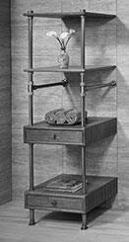INCLUDES:
(2) 6"D DRAWERS (2) WOOD SHELVES
CEMENT GRAY WOOD

AGED BRASS
CEMENT GRAY WOOD

4670

DIMS: 36"W x 22"D x 72"H WEIGHT APPROX 120LBS

PFS-STGSLF-24 PNCA PFS-STGSLF-24 PNAGL PFS-STGSLF-24 ABCA
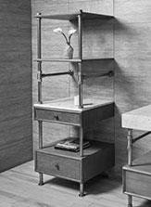PFS-STGSLF-24 ABAGL

VERGE STORAGE SET WITH STONE SHELF, 24W

INCLUDES:
(1) 6"D DRAWER, (1) 10"D DRAWER (2) WOOD SHELVES
(1) STONE SHELF
POLISHED NICKEL CEMENT GRAY WOOD CARRARA MARBLE
POLISHED NICKEL CEMENT GRAY WOOD ANTIQUE GRAY LIMESTONE
AGED BRASS
CEMENT GRAY WOOD CARRARA MARBLE
AGED BRASS
CEMENT GRAY WOOD ANTIQUE GRAY LIMESTONE
5302

5212

4964

4874
DIMS: 24"W x 22"D x 72"H
WEIGHT APPROX 120LBS

DESCRIPTION COLOR PRICE

PFS-STGSLF-36 PNCA PFS-STGSLF-36 PNAGL PFS-STGSLF-36 ABCA
PFS-STGSLF-36 ABAGL

VERGE STORAGE SET WITH STONE SHELF, 36W

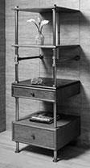INCLUDES:
(1) 6"D DRAWER, (1) 10"D DRAWER (2) WOOD SHELVES
(1) STONE SHELF
POLISHED NICKEL CEMENT GRAY WOOD CARRARA MARBLE
POLISHED NICKEL CEMENT GRAY WOOD ANTIQUE GRAY LIMESTONE
AGED BRASS
CEMENT GRAY WOOD CARRARA MARBLE
AGED BRASS
CEMENT GRAY WOOD ANTIQUE GRAY LIMESTONE
5712

5612

5374

5274
DIMS: 36"W x 22"D x 72"H WEIGHT APPROX 120LBS

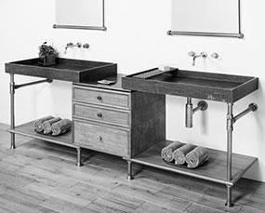

FIG A

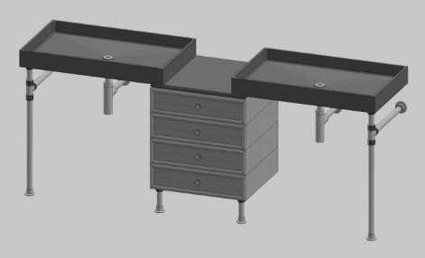

FIG B

VERGE DOUBLE VANITY, 89W [FIG A] (2) 36"W VERGE BATH SINK
(2) WOOD SHELVES
(2) 6"D DRAWER, (1) 10"D DRAWER (1) STONE SHELF

VERGE DOUBLE VANITY, 89W [FIG B] (2) 36"W VERGE BATH SINK
(4) 6"D DRAWERS (1) STONE SHELF

ANTIQUE GRAY LIMESTONE AGED BRASS
CEMENT GRAY WOOD
ANTIQUE GRAY LIMESTONE POLISHED NICKEL
CEMENT GRAY WOOD
CARRARA MARBLE AGED BRASS
CEMENT GRAY WOOD
CARRARA MARBLE POLISHED NICKEL CEMENT GRAY WOOD
ANTIQUE GRAY LIMESTONE AGED BRASS
CEMENT GRAY WOOD
ANTIQUE GRAY LIMESTONE POLISHED NICKEL
CEMENT GRAY WOOD
CARRARA MARBLE AGED BRASS
CEMENT GRAY WOOD
CARRARA MARBLE POLISHED NICKEL CEMENT GRAY WOOD

8630

8929

9320

9619

8446

8740

9136

9430
DIMS: 89"W x 22"D x 36"H WEIGHT APPROX 200LBS
Pricing is for custom double vanities as shown. Please contact us for assistance ordering these or other configurations.
TD-VNT-36 AGL
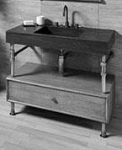+PFS-TDD10-24 AB

TD-VNT-36 AGL
+PFS-TDD10-24 PN

TD-VNT-36 CA
+PFS-TDD10-36 AB

TD-VNT-36 CA
+PFS-TDD10-36 PN

ELEMENTAL VANITY WITH STORAGE,
36W

INCLUDES: ELEMENTAL VANITY VERGE 2 LEG STAND (1) 10"D DRAWER
AGED BRASS
CEMENT GRAY WOOD ANTIQUE GRAY LIMESTONE
POLISHED NICKEL CEMENT GRAY WOOD ANTIQUE GRAY LIMESTONE
AGED BRASS
CEMENT GRAY WOOD CARRARA MARBLE
POLISHED NICKEL CEMENT GRAY WOOD CARRARA MARBLE
4583

4743

4808

4968
DIMS: 36"W x 22"D x 36"H WEIGHT APPROX 120LBS
TD-VNT-24 AGL
+PFS-TDD10-24 AB

TD-VNT-24 AGL
+PFS-TDD10-24 PN

TD-VNT-24 CA
+PFS-TDD10-24 AB

TD-VNT-24 CA
+PFS-TDD10-24 PN

ELEMENTAL VANITY WITH STORAGE,
24W

INCLUDES: ELEMENTAL VANITY VERGE 2 LEG STAND (1) 10"D DRAWER

AGED BRASS
CEMENT GRAY WOOD ANTIQUE GRAY LIMESTONE
POLISHED NICKEL CEMENT GRAY WOOD ANTIQUE GRAY LIMESTONE
AGED BRASS
CEMENT GRAY WOOD CARRARA MARBLE
POLISHED NICKEL CEMENT GRAY WOOD CARRARA MARBLE

3973

4133

4123

4283
CONTACT:
DIMS: 24"W x 22"D x 36"H WEIGHT APPROX 120LBS

CODE DESCRIPTION COLOR PRICE
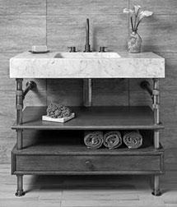TD-VNT-36 AGL
+PFS-TDD6SLF-36 AB

TD-VNT-36 AGL
+PFS-TDD6SLF-36 PN

TD-VNT-36 CA
+PFS-TDD6SLF-36 AB

TD-VNT-36 CA
+PFS-TDD6SLF-36 PN

ELEMENTAL VANITY
WITH STORAGE AND SHELF, 36W

INCLUDES: ELEMENTAL VANITY VERGE 2 LEG STAND (1) 6"D DRAWER
(1) WOOD SHELF

SPECIFY FAUCET HOLE(S) IF NEEDED WHEN ORDERING
AGED BRASS
CEMENT GRAY WOOD ANTIQUE GRAY LIMESTONE
POLISHED NICKEL CEMENT GRAY WOOD ANTIQUE GRAY LIMESTONE
AGED BRASS
CEMENT GRAY WOOD CARRARA MARBLE
POLISHED NICKEL CEMENT GRAY WOOD CARRARA MARBLE
4913

5073

5138

5298
DIMS: 36"W x 22"D x 36"H WEIGHT APPROX 120LBS
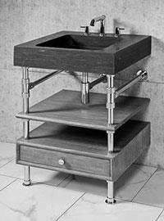TD-VNT-24 AGL
+PFS-TDD6SLF-24 AB

TD-VNT-24 AGL
+PFS-TDD6SLF-24 PN

TD-VNT-24 CA
+PFS-TDD6SLF-24 AB

TD-VNT-24 CA
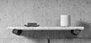+PFS-TDD6SLF-24 PN

ELEMENTAL VANITY
WITH STORAGE AND SHELF, 24W

INCLUDES: ELEMENTAL VANITY VERGE 2 LEG STAND (1) 6"D DRAWER
(1) WOOD SHELF

SPECIFY FAUCET HOLE(S) IF NEEDED WHEN ORDERING

AGED BRASS
CEMENT GRAY WOOD ANTIQUE GRAY LIMESTONE

POLISHED NICKEL CEMENT GRAY WOOD ANTIQUE GRAY LIMESTONE

AGED BRASS
CEMENT GRAY WOOD CARRARA MARBLE

POLISHED NICKEL CEMENT GRAY WOOD CARRARA MARBLE

4303

4463

4453

4613
DIMS: 24"W x 22"D x 36"H WEIGHT APPROX 120LBS

PFS-ACSPTRY ACCESSORY SOAP TRAY
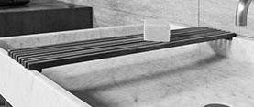(FOR USE WITH VERGE SINKS)

CEMENT GRAY TEAK 75

DIMS: 5"W x 22"D WEIGHT APPROX 5 LBS

STONE SHELF
WITH METAL SUPPORTS

ANTIQUE GRAY LIMESTONE
AGED BRASS 565

ANTIQUE GRAY LIMESTONE
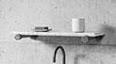POLISHED NICKEL 595

CARRARA MARBLE
AGED BRASS 595

CARRARA MARBLE
POLISHED NICKEL 625

DIMS: 24"W x 6"D WEIGHT APPROX 10 LBS

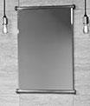PFS-TB-25MI PN PFS-TB-25MI AB
VERGE TUBE MIRROR
(FOR 25"W MIRRORS)
POLISHED NICKEL AGED BRASS
690
645

DIMS: 25"W x 1.25"D WEIGHT APPROX 15 LBS

CODE DESCRIPTION COLOR / SIZE PRICE
VERGE CUSTOMIZATION - SINKS & STANDS

PFS-TDST PN PFS-TDST AB

TD-THN-24 AGL TD-THN-24 CA TD-THN-36 AGL TD-THN-36 CA

TD-THN-FCT-24 AGL TD-THN-FCT-24 CA TD-THN-FCT-36 AGL TD-THN-FCT-36 CA

SIMPLE STAND SETUP
(FOR 36" & 24" SINKS - STAND ONLY)

VERGE THIN WALLED BATH SINK
(24" & 36" WIDTHS - SINK ONLY)

VERGE THIN WALLED BATH SINK WITH FAUCET DECK
(24" & 36" WIDTHS - SINK ONLY)
SEE BELOW FOR FAUCET HOLE DRILLING CHARGES

POLISHED NICKEL AGED BRASS

ANTIQUE GRAY LIMESTONE CARRARA MARBLE
ANTIQUE GRAY LIMESTONE CARRARA MARBLE

ANTIQUE GRAY LIMESTONE CARRARA MARBLE
ANTIQUE GRAY LIMESTONE CARRARA MARBLE
1600
1460

1275
1490
1500
1850

1300
1515
1575
1875

TD-VNT-24 AGL TD-VNT-24 CA TD-VNT-36 AGL TD-VNT-36 CA

VERGE CUSTOMIZATION - STORAGE
ELEMENTAL VANITY SINK (24" & 36" WIDTHS - SINK ONLY) SEE BELOW FOR FAUCET HOLE DRILLING CHARGES
ANTIQUE GRAY LIMESTONE CARRARA MARBLE
ANTIQUE GRAY LIMESTONE CARRARA MARBLE
1500
1650
1950
2175

NOTE: SHELVES & DRAWERS REQUIRE USE OF SUPPORT COLLARS BELOW ITEMS ($68 AGED BRASS/ EA - $72 POLISHED NICKEL/ EA). ADDITIONAL SUPPORT COLLARS CAN BE USED DECORATIVELY ABOVE DRAWERS AND SHELVES.

PFS-DRWR-246
PFS-DRWR-2410
SINGLE WOOD DRAWER UNIT 24"W
(FOR USE WITH 24"W STAND)
6" DEEP DRAWER
10" DEEP DRAWER
690
730

PFS-DRWR-366
PFS-DRWR-3610
PFS-DVD
SINGLE WOOD DRAWER UNIT 36"W
(FOR USE WITH 36"W STAND)
6" DEEP DRAWER
10" DEEP DRAWER
820
860

GLASS DRAWER DIVIDERS
(FOR USE IN 6" DEEP DRAWERS) SMOKE GLASS 260

PFS-MTTRY-24
PFS-MTTRY-36
FOLDED METAL SHELF
(TUXEDO GRAY METAL)
24" WIDTH
36" WIDTH
550
590

PFS-WDSLF-24
PFS-WDSLF-36

PFS-STSLF-24 AGL PFS-STSLF-24 CA PFS-STSLF-36 AGL PFS-STSLF-36 CA

PFS-KNOB PN PFS-KNOB AB
WOOD VANITY SHELF
(CEMENT GRAY WOOD)

STONE VANITY SHELF (24" & 36" WIDTHS)

CABINET KNOBS WITH KNURLED DETAIL (PRICED PER EACH)
24" WIDTH
36" WIDTH

ANTIQUE GRAY LIMESTONE CARRARA MARBLE
ANTIQUE GRAY LIMESTONE CARRARA MARBLE

POLISHED NICKEL AGED BRASS
340
370

380
470
460
560

45
41

VERGE CUSTOMIZATION - SERVICE CHARGES AND FAUCET DRILLING

DRILL CH

DRILL 2H DRILL 3H
FAUCET HOLE DRILLING SPECIFIY LOCATION AND QUANITY WHEN ORDERING
SINGLE HOLE
TWO HOLES THREE HOLES
50
75
100

PAINTED PAINTING FOR WOOD DRAWER AND SHELF UNITS

SELECT FROM
AVAILABLE COLORS 400

