Arno & Panaro

New MAAX Professional Drop-In Bathtubs

We are pleased to announce that the MAAX Professional lineup will feature the new Arno 6040, Arno 7242, Panaro 6042 and Panaro 7242 drop-in bathtubs. Featuring traditional design and flexibility with choices in size and options, these bathtubs are an exciting addition to the MAAX Professional Trade Acrylic Lineup.

Upon launch, these new MAAX bathtubs will only be offered in soaker versions. For the short term, customers will be able to continue to order the Twilight, Tympani, Talisman and Temple if a system configuration is desired.

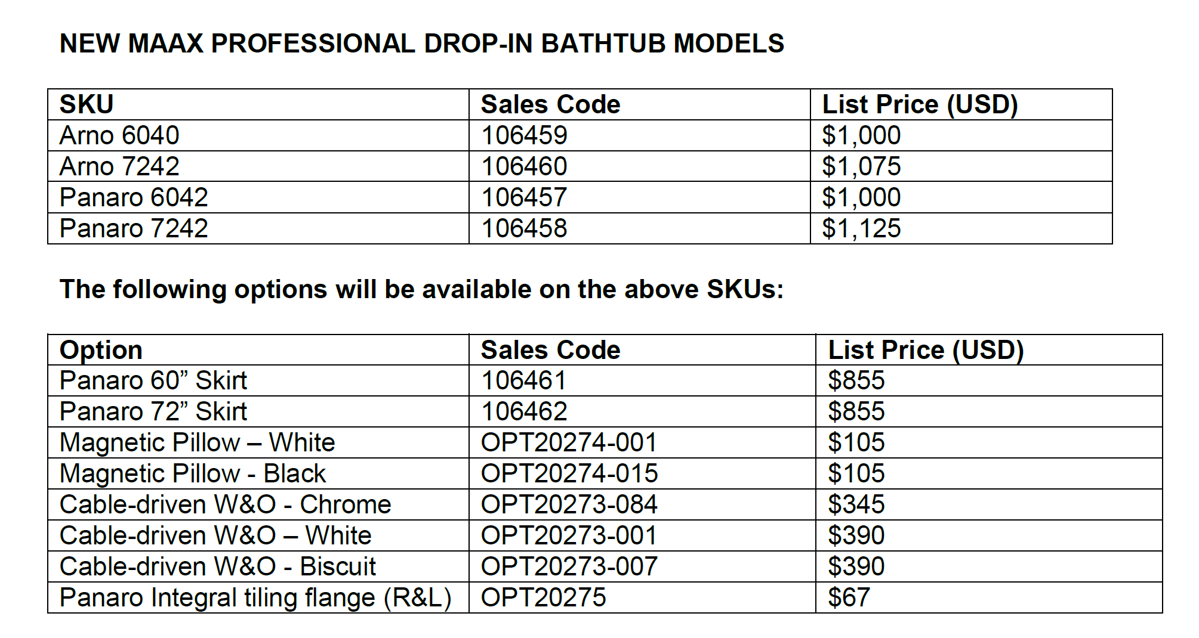

ARNO 6040
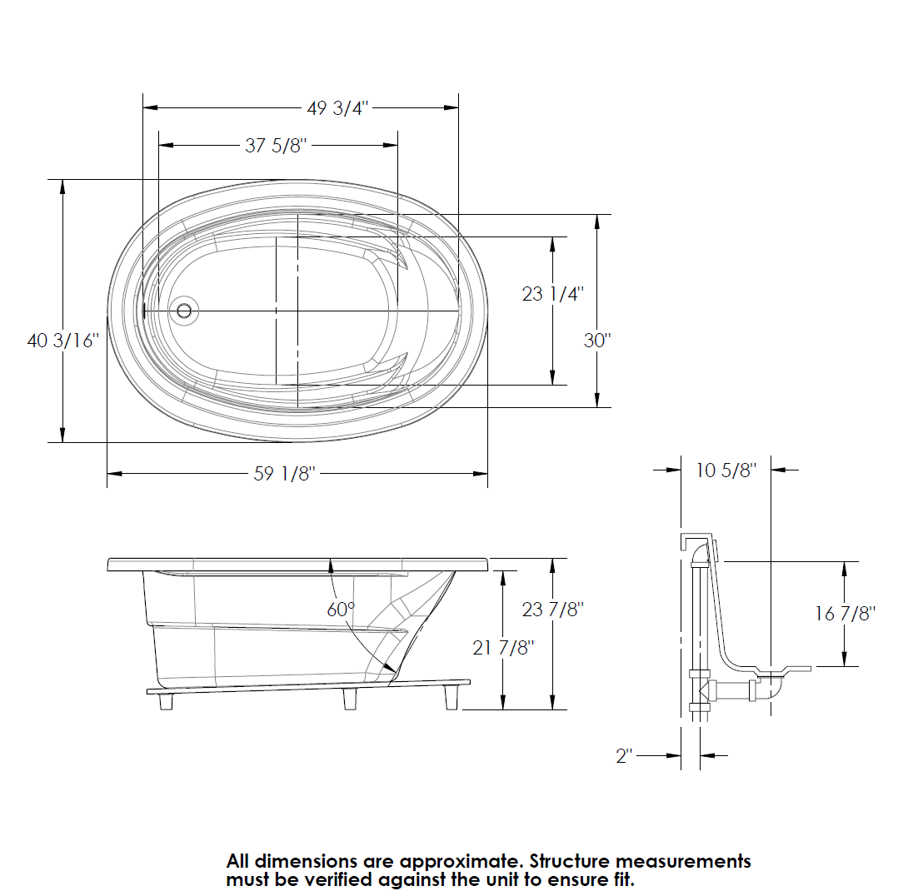

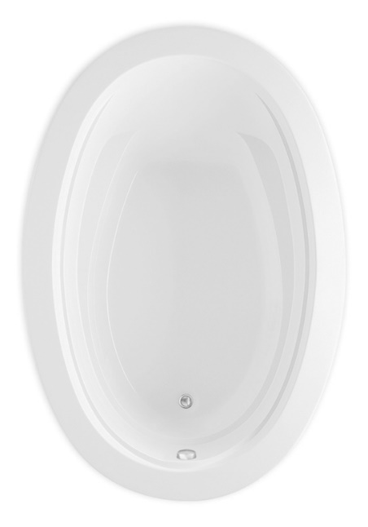
ARNO 7242
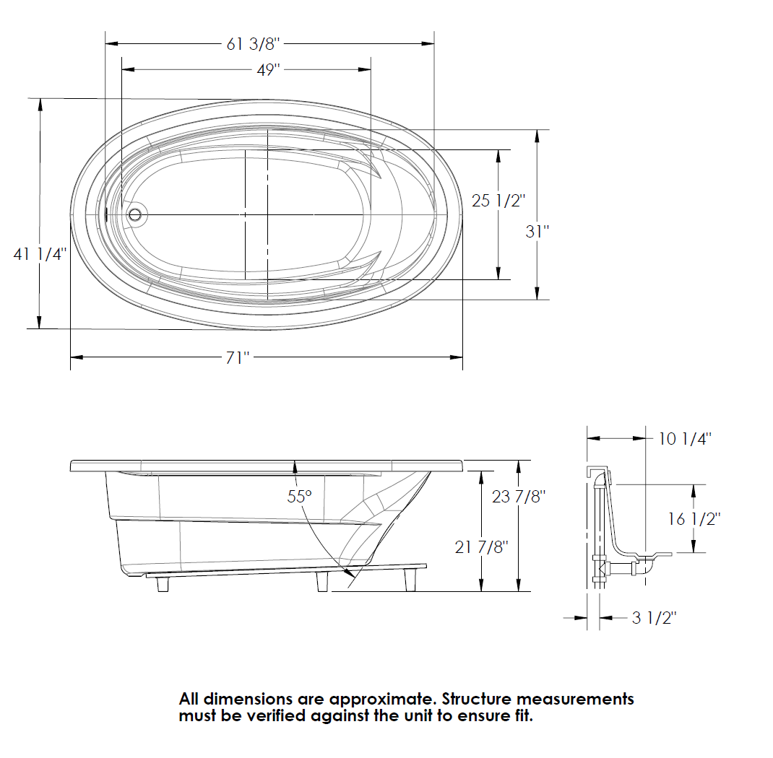

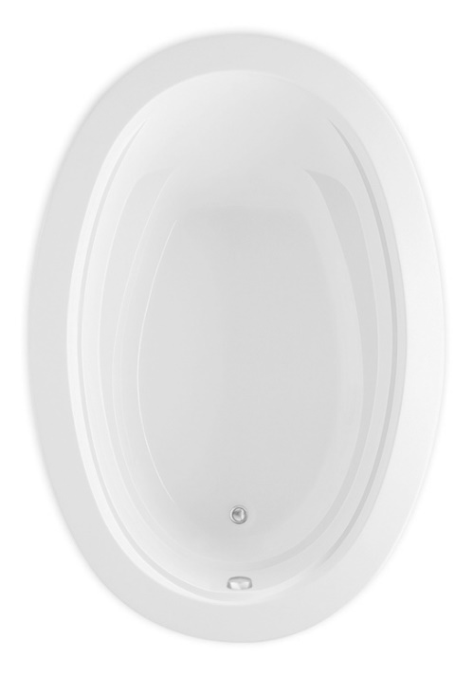
PANARO 6042
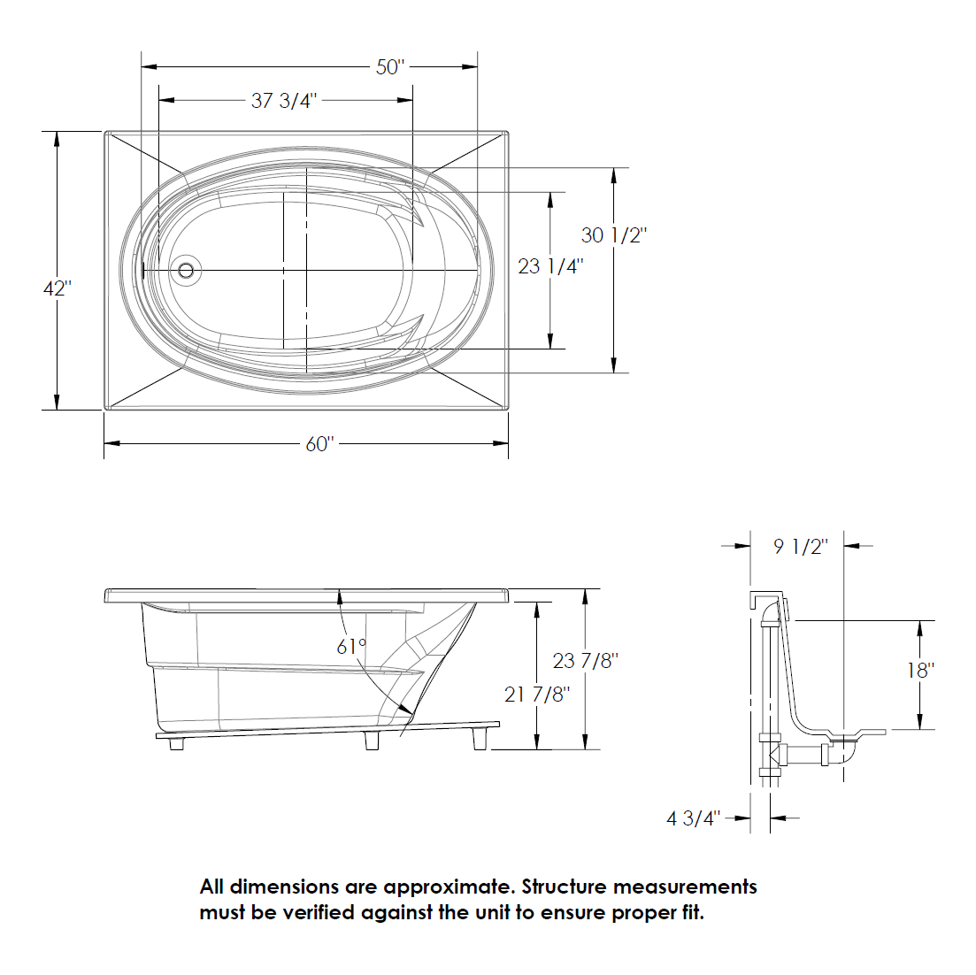
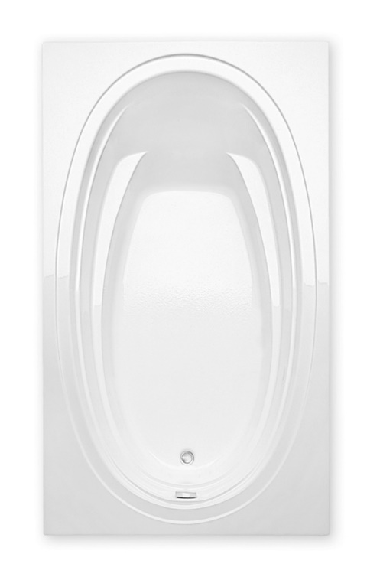
PANARO 7242
