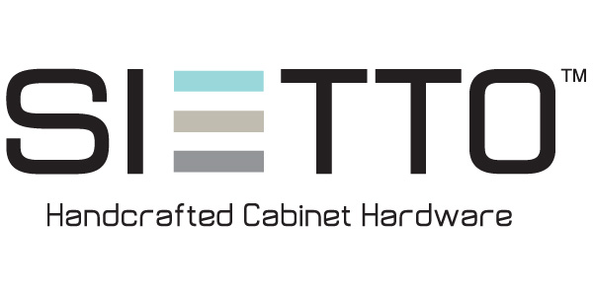

SUGGESTED LIST PRICING FOR SERIES 100 THROUGH 1100 -- EFFECTIVE FEBRUARY 1, 2018

All square knobs -- $20
All round knobs -- $21
All long knobs -- $23
All pulls -- $29

SUGGESTED LIST PRICING FOR SERIES 1200, 1300, 1400, 1500, 1600 and 1700 -- EFFECTIVE FEBRUARY 1, 2018

All knobs in the 1200 series -- $33
All pulls in the 1200 series -- $45
All knobs in the 1300 series -- $25
1400 series knob -- $20
1400 series pull -- $29
1500 series long knob -- $23
1500 series pull -- $29
All knobs in the 1600 series -- $27
All Hexagon knobs (1700 series) -- $27
All 1800 series pulls -- $45
All 1800 series knobs -- $25

All Sietto hardware is handcrafted and made to order. Thus, our products are non returnable. If your customer is not sure if a color will work, we recommend ordering a sample piece before placing an order.

------------------------------------------------------------------------------------------------------------
1100 West Cermak Road, Suite C-550, Chicago, IL 60608
312-513-6968 (phone)
312-226-9710 (fax)
www.sietto.com

