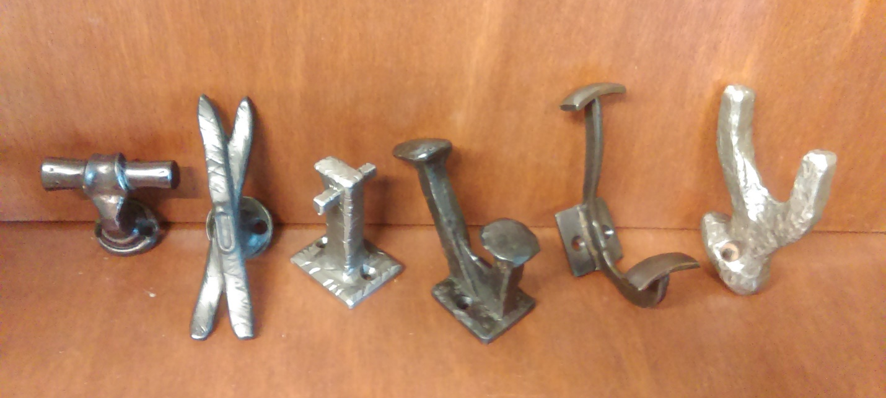
2 5 6
1 3 4

Hook List….Suggested retail for all $36.95
1. WH-106 Oil-Rubbed Bronze
2. WH-100 Antique Pewter
3. WH-102 Antique Pewter
4. WH-103 Oil-Rubbed Bronze
5. WH-101 Oil-Rubbed Bronze
6. WH-105 Antique Pewter

