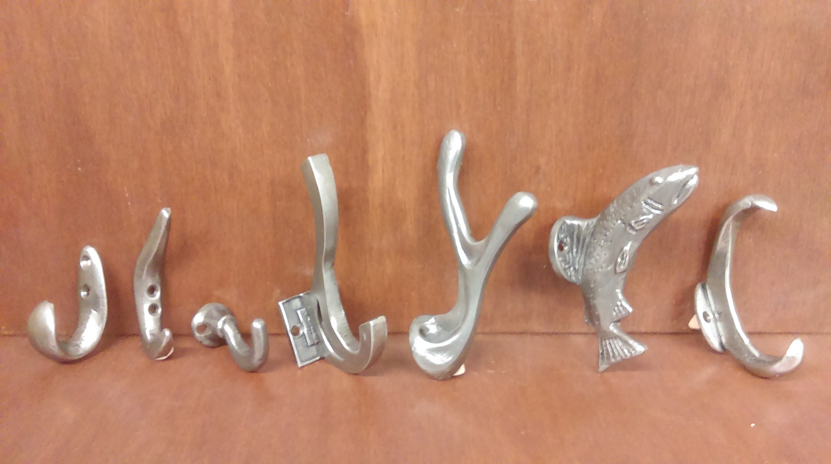

1 2 3 4 5 6 7

Pricing in suggested retail cost.
1. WH-107…SP….small contemporary hook….$14.95
2. WH-108…SP….small double hook….$14.95
3. WH-109…SP….small hook……………..$14.95
4. WH-110…AP….modern double hook…..$36.95
5. WH-111…AP….antler double hook…….$36.95
6. WH-112…AP….fish hook……………..$36.95
7. WH-113…SP….double contemporary hook….$34.95

