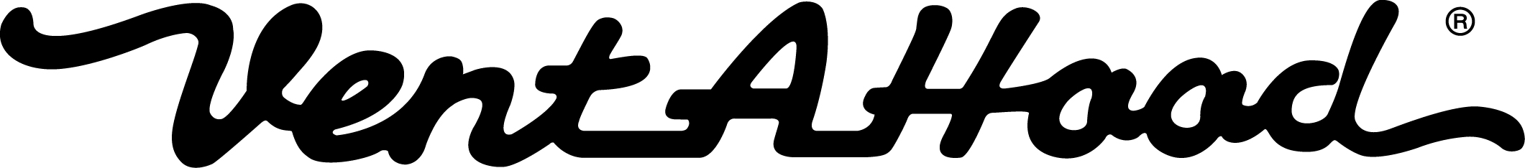

Vent-A- Hood UMRP Policy Effective October 1st, 2017

Vent-A-Hood Ltd. has determined that in order to better maintain its brand image, it must exercise a greater degree of control over the distribution of its products. Therefore, all sales of Vent-A-Hood products by Vent-A-Hood’s authorized retailers will be subject to this Distribution Policy. This Policy has been unilaterally adopted and will be enforced strictly and uniformly.

Although resellers remain free to establish their own resale prices, Vent-A-Hood will, without assuming any liability, cancel all orders and will indefinitely refuse to accept any new orders from any reseller immediately following Vent-A-Hood’s verification to its satisfaction that such reseller has advertised, offered, or sold any Vent-A-Hood products at a net retail sales price less than the minimum retail price established and announced by Vent-A-Hood from time to time (the “Floor Price”). A retailer determined to be in violation of this Policy will not be allowed to purchase Vent-A-Hood products for one year. Reinstatement as a Vent-A-Hood authorized retailer, however, will not be dependent on any agreement or promises to comply with this Policy.

The Floor Price is the current list price for each product as stated on Vent-A-Hood’s price list, exclusive of all state and local taxes.

This Policy applies to all of Vent-A-Hood’s first-quality goods. It does not apply to used, damaged, uncrated, or display products. This Policy also does not apply to approved pricing for builder projects, model homes, parade of homes, or personal use.

This Policy may be modified at any time by Vent-A-Hood, and the Floor Price may be affected by promotions announced by Vent-A-Hood or may change during promotional periods designated by Vent-A-Hood.

Vent-A-Hood will not discuss any conditions of acceptance related to this Policy, as it is non-negotiable and will not be altered for any reseller. In addition, Vent-A-Hood neither solicits, nor will it accept, any assurance of compliance with this Policy. Vent-A-Hood is not seeking agreement from any retailer to adhere to this policy. It is entirely within the retailer’s discretion whether to comply with the minimum price. Nothing in this Policy shall constitute an agreement between Vent-A-Hood and any reseller that the reseller will comply with this Policy.

Vent-A-Hood sales personnel have no authority to modify or grant exceptions to this Policy. All questions regarding the interpretation of this Policy must be directed to Vent-A-Hood’s policy administrator, Miles Woodall III, President and CEO of Vent-A-Hood Ltd.

