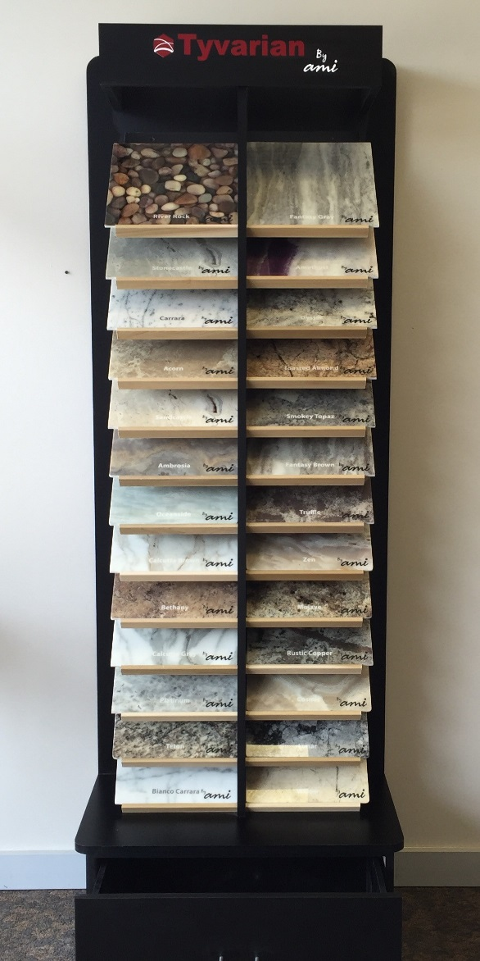
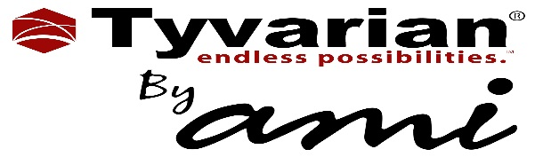

Sample Program
- Full Set of 25 Samples in Boxes: $500 List Price
- Sample Tower 30” x 19” x 84”: $370 List Price
- Individual 12” x 12” Sample: $50 List Price
- 3% of Tyvarian sales 12 months will be credited to offset sample cost.

