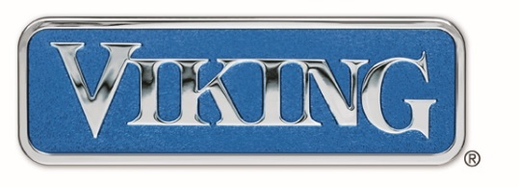
DATE: March 8, 2016
SUBJECT: Viking Professional Series Warranty
Effective April 1, 2016 all Viking Professional products will receive a Two Year warranty. This will be indicated with the following serial number logic. NOTE: Canadian product has a "C" in the prefix :
For all products manufactured prior to this date, with serial numbers lower than a 040116 prefix, Viking will honor the warranty stated in the literature packaged with the unit. In addition, for any builder projects that ship prior to the April 1, 2016 effective date, or prior to the effective serial number shown, Viking will honor with the warranty packaged in the product. Again, this affects the Viking Professional Series and Tuscany Series only. The Viking Outdoor Product remains unchanged with the Two‐Year warranty and the Viking (3 Series) products, FDW Dishwashers and VDD downdrafts will remain unchanged, with a One‐Year warranty.

A Two‐Year warranty on Viking Professional products places us on the same level playing field as our key competitors and provides our consumers with a point of differentiation regarding warranty between our Professional and 3‐Series offerings. Research has shown that the consumer does not place heavy emphasis on a three‐year warranty, however they do place heavy emphasis on the after‐sale service/customer service experience. Viking is investing significantly in our infrastructure for post‐sale support and parts availability. Our goal is to elevate Viking’s consumer experience
to be best‐in‐class and serve our dealers in a manner that is “easy to do business with”!

