Barz Decorative Hardware
Giving you a voice in your home…

Product Information

- Telling our story
Owners Pete and Elizabeth Barszcz design and manufacture all products in Silverton, Colorado, at 9,300 feet above sea level.
- Knowing our product
All pieces are cast out of pewter. All pieces available in over 22 finishes. Product line sets include knobs, oversized knobs, pulls (3”, 4”, 6”, 10”), and appliance pulls. We offer an expansive collection in a variety of styles including; contemporary, modern, rustic, traditional, and fused glass.
- Understanding our goals
We strive to help our small, rural community by employing skilled laborers. We strive to help our earth by using eco-friendly materials. We strive to help our country by manufacturing in the U.S.A.
- Helping customers
At Barz we can create nearly any design your client wants, whether it is modifying a design we already have, duplicating an antique, or creating a new idea straight from the customer.
Distributors, designers, and customers can call and talk to us directly about our products, their projects, or new ideas to help make their Barz experience the best. Our design and manufacturing foundry is open to the public and used as an educational headquarters.

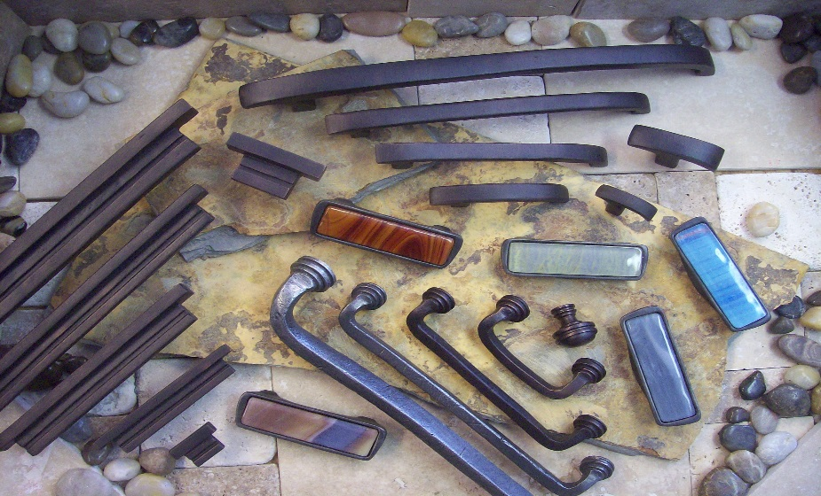

- Call us directly anytime with questions: 970-387-5173 or Pete directly at 970-749-7956

